RESPIRATORY PHYSIOLOGY

Course outline
- Definition
- Functional Anatomy
- Pulmonary ventilation
- Alveolar-capillary diffusion (hematosis)
- Transport of respiratory gases
- Cellular respiration
- Pulmonary circulation
- Ventilation control
Definition
Respiration is the set of mechanisms that transport an adequate amount of oxygen from the environment to the cells and release carbon dioxide produced by cellular metabolism into the atmosphere . Respiration occurs in four phases:
- Pulmonary ventilation allows for gas exchange between the lungs and the ambient air .
- Alveolar-capillary diffusion (Hematosis) allowing the passage of gases from the air in the alveoli into the blood capillaries
- _{O2} is transported via the bloodstream, which is responsible for transporting oxygen to the various cells of the body.
- Cellular respiration during which the cell uses oxygen and releases CO2 , which follows a path opposite to that of oxygen, resulting in its pulmonary excretion .

1. Functional Anatomy
1.1. Rib cage
The rib cage is a hollow, airtight, and deformable elastic enclosure. It includes the inspiratory and expiratory muscles.

Inspiratory muscles | Expiratory muscles
- Diaphragm (++)  -External intercostal muscles  -Accessory muscles ( sternocleidomastoid , scalene muscles)  They allow the cage to be widened at the top. | - External intercostal muscles  -Abdominal muscles (Internal oblique muscle, external oblique muscle, rectus abdominis muscle)  These three abdominal muscles are used when one wants to increase exhalation.

Inspiratory muscles
The diaphragm is the most important muscle of inspiration. When the diaphragm contracts, the abdominal contents are pushed downwards and the ribs are lifted upwards and outwards.
The external intercostal muscles and accessory muscles are not used for inspiration during normal, calm breathing. They are used during exercise.

Expiratory muscles
Expiration is normally passive because the lung/rib cage system is elastic; it returns to its resting position. after taking a breath. The expiratory muscles are used during exercise. or when the resistance of the paths airborne transmission is increased due to an illness (for example, in the case of asthma).
The abdominal muscles compress the abdominal cavity, push the diaphragm upwards and expel air from the lungs.
The internal intercostal muscles pull the ribs downwards and inwards.

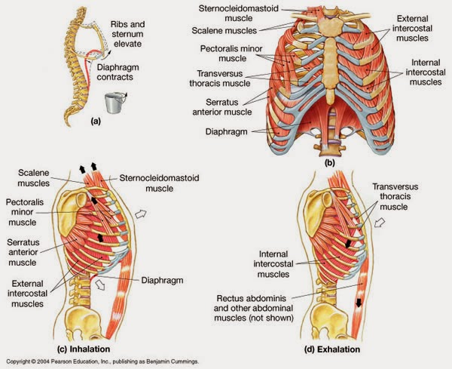

There are two functional zones in the lungs:
- A conduction zone
It is represented by the airways. This includes the mouth, nose, pharynx, larynx, trachea, bronchi, and bronchioles. It ensures the conduction of inhaled air to the respiratory zone. It also allows for warming. humidification , filtration and purification of inhaled air.
The upper airways are composed, from top to bottom, of:
- Nose
- Mouth
- Pharynx
- Larynx

The lower airways constitute the bronchial tree; they include:
- Trachea
- Bronchi

Bronchial tree
The airways in the lungs branch approximately 23 times in succession (in humans). This branching of the airways is often called the bronchial or respiratory tree.
The trachea divides to form the right and left main bronchi , each running obliquely through the mediastinum before entering the hilum of the lung.
Once they enter the lungs, the main bronchi subdivide into lobar bronchi , one for each lung lobe. The lobar bronchi give rise to segmental bronchi , which branch off into increasingly smaller bronchi. Airways measuring less than 1 mm in diameter are called bronchioles ; they enter the lung lobules . The bronchioles further subdivide into terminal bronchioles, which measure less than 0.5 mm in diameter.

- A respiratory zone
It is represented by the lung parenchyma. This includes the bronchioles, alveolar ducts, and alveolar sacs, where gas exchange takes place (thanks to 300 million alveoli). This area represents a large surface area for air diffusion (70 m² ⁾ .

1.2. The lungs are paired organs located within the thoracic cavity. The interstitial stroma divides the lung parenchyma into progressively smaller lobules. Each lobule has a fine bronchial branch, the terminal bronchiole, which divides into 2 or 4 respiratory bronchioles. These conduct air to the alveoli via the alveolar ducts.
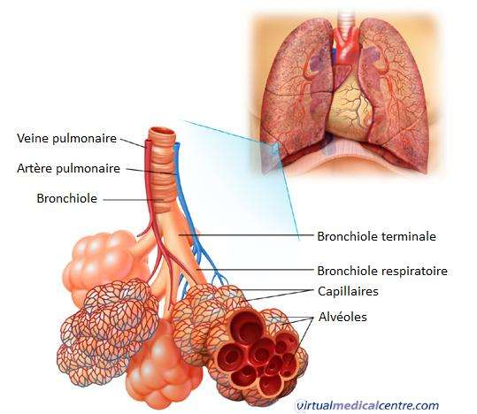
The alveoli are tightly packed together, separated by very thin septa , and open on either side of the alveolar duct. The walls of the alveoli are lined by type I alveolar cells, which constitute the respiratory epithelium . Scattered among these cells are specialized cells called type II alveolar cells, which synthesize surfactant .

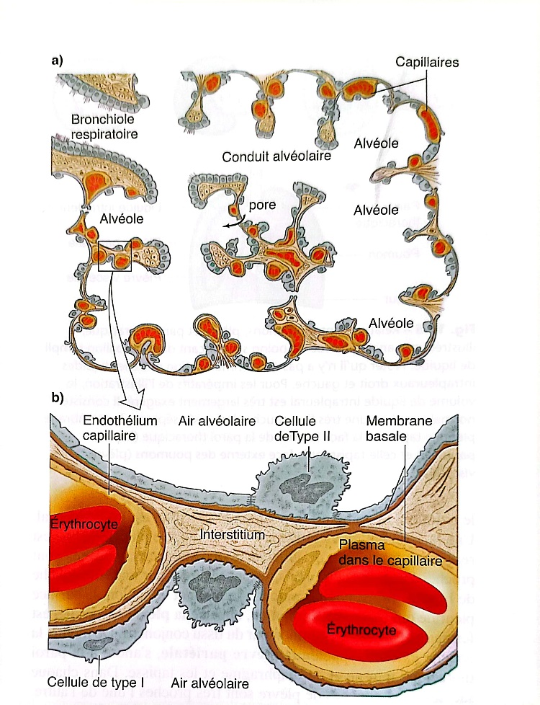
The alveolar epithelium rests on a delicate network of collagen and elastic fibers, which are themselves in direct contact with the endothelium of the pulmonary capillary network. Gas exchange between alveolar air and capillary blood occurs through these thin tissue layers.
1.3. The pleura
The lungs are surrounded by a serous lining made up of connective tissue, elastic fibers, and smooth muscle fibers called the pleura. The pleura consists of two layers:
- A parietal layer (which envelops the thoracic cavity and the upper surface of the diaphragm ).
- A visceral layer (which envelops the lung)

Between these two layers lies the pleural cavity, lined by a film of fluid (pleural fluid) that allows the lungs to slide and thus move up and down. Negative pressure exists within the pleural cavity.
The pleural layers can easily slide against each other, but the surface tension of the pleural fluid strongly resists their separation. Consequently, each lung adheres firmly to the chest wall and expands and contracts according to the changes in volume of the thoracic cavity, which increase during inspiration and decrease during expiration.

1.4. Vascularization
There are two pulmonary circulatory systems:
- A nourishing system or bronchial circulation.
- A functional system or pulmonary circulation.

1.4.1. Bronchial circulation:
Its primary function is to oxygenate the pulmonary structures (bronchi and lung parenchyma). This function is carried out by the bronchial vessels that follow the bronchi, and it is part of the systemic circulation (1% of cardiac output). It originates from the bronchial artery and refers to capillary networks distributed throughout the interstitial tissue. This system also irrigates the interstitium , pleura, lymph nodes, and bronchial walls. Venous blood is returned via the bronchial veins.

1.4.2. Pulmonary circulation
It facilitates alveolar-capillary gas exchange. And therefore the oxygenation of the blood and the removal of _{CO2} .
She comes from The pulmonary artery branches within the interstitial septa, reaching the pulmonary lobules into which it enters. The venous capillaries then merge into venules, which become veins that run parallel to the arteries and bronchi within the interstitial stroma, returning oxygenated blood to the left atrium.

2. Lung volumes
2.1. Tidal volume: this is the volume inhaled or exhaled with each normal respiratory movement.
2.2. Inspiratory reserve volume: this is the volume that can be inspired in addition to the tidal volume, It is used during exercise.
2.3. Expiratory reserve volume: this is the volume that can be exhaled after expiration of the tidal volume.
2.4. Residual volume: this is the volume that remains in the lungs after a maximal expiration.
2.5. Dead space
During a resting breath, we inhale an average of 500 ml of air. Only 350 ml reaches the alveoli. This is because 150 ml does not participate in the alveolar-capillary gas exchange. This is referred to as a dead space, which does not contribute to gas exchange.
2.5.1. Anatomical dead space
It corresponds to the airways. It is normally about 150 mL .
2.5.2. Physiological dead space
This is a functional quantity, represented by all ventilated but non-perfused spaces. It is defined as the volume of the lung that does not eliminate CO2 . It can be larger than the anatomical dead space in cases of pulmonary disease when there are imbalances in the ventilation/perfusion ratio.

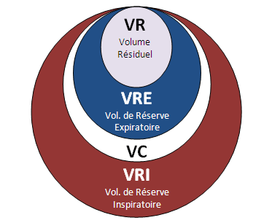

Ventilatory flow rate
Minute ventilation expressed as follows:
Ventilation per minute = tidal volume x number of breaths per minute

Alveolar ventilation expressed as follows:
Alveolar ventilation = (tidal volume - dead space) x number of breaths per minute

3. Lung capacity
3.1. Inspiratory capacity
It is the sum of the tidal volume and the inspiratory reserve volume.
3.2. Functional Residual Capacity (FRC)
It is the sum of the expiratory reserve volume and the residual volume. It is the volume remaining in the lungs after exhaling a tidal volume.
3.3. Vital Capacity
It is the sum of the tidal volume, the inspiratory reserve volume, and the expiratory reserve volume. This is the maximum volume that is exhaled after a maximum inhalation.
3.4. Total lung capacity
It is the sum of the four lung volumes. It is the volume in the lungs after a maximal inspiration. It includes the residual volume, so it cannot be measured by spirometry .

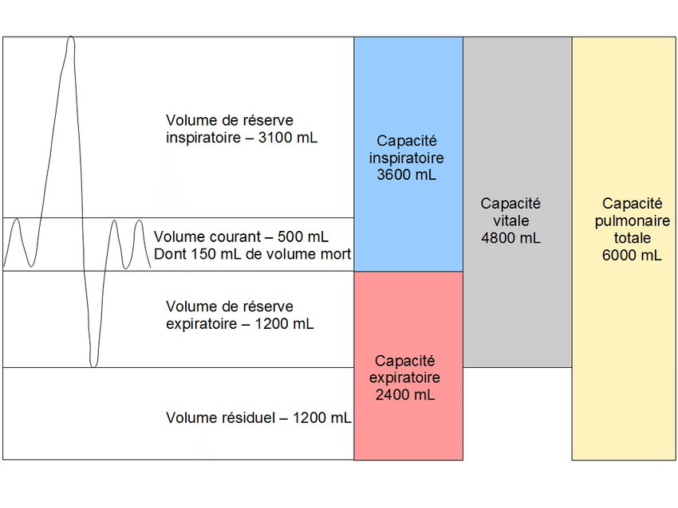
4. Mechanics of pulmonary ventilation
Ventilation is defined as the exchange of air between the atmosphere and the alveoli. The driving force behind ventilation, and therefore gas exchange, is the pressure difference between the alveoli and the ambient air. Airflow is defined by the following equation:
Q = ΔP/R
Q = P _{atm} - P _{alv} / R
Q: Airflow
P _{atm} : atmospheric pressure
P _{alv} alveolar pressure
R: Airway resistance

At rest, there is no airflow:
Q = 0
P _{atm} - P _{alv} = 0
P _{atm} = P _{alv} = 760 mmHg

Intrapleural pressure is negative and lung volume is the functional residual capacity (FRC).
During ventilation, air enters and leaves the lungs because the alveolar pressure alternately falls below and rises above atmospheric pressure.
If we assume that P _{atm} is equal to 0, it follows that P _{alv} is negative during inspiration and positive during expiration. To achieve these pressures, lung volume must increase during inspiration and decrease during expiration. This is ensured by the movements of the diaphragm and rib cage.
During inspiration : the inspiratory muscles contract and cause the thorax to expand. The lung volume increases by a tidal volume (FRC+VC).
Intrapleural pressure becomes even more negative during inspiration and alveolar pressure becomes lower than atmospheric pressure.
During exhalation: the opposite occurs
The P _{alv} becomes greater than the atmospheric P and the intrapleural pressure returns to its resting value during a normal expiration.
The lung volume returns to the FRC before another cycle begins.
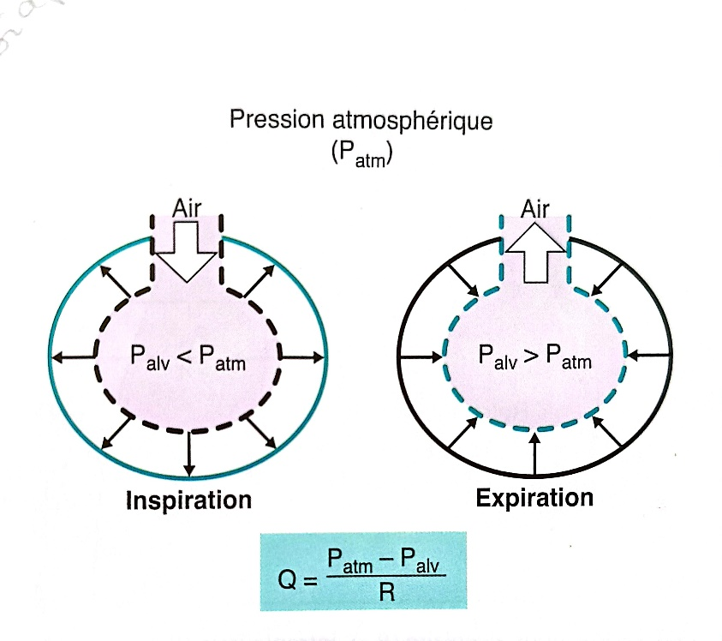
To understand how a change in lung dimensions induces a variation in alveolar pressure, one must refer to the ideal gas law BOYLE.
At constant temperature, the relationship between the pressure exerted by a fixed number of gas particles and the volume of their container is as follows: an increase in the volume of the container decreases the pressure of the gas and vice versa.
P1V1 = _{P2V2​}​​​​

4.1. Respiratory system compliance
Lung compliance​ This is the lung's capacity to expand. It is the magnitude of the change in lung volume for a given change in transpulmonary pressure . This compliance is represented by the slope of the pressure-volume curve.

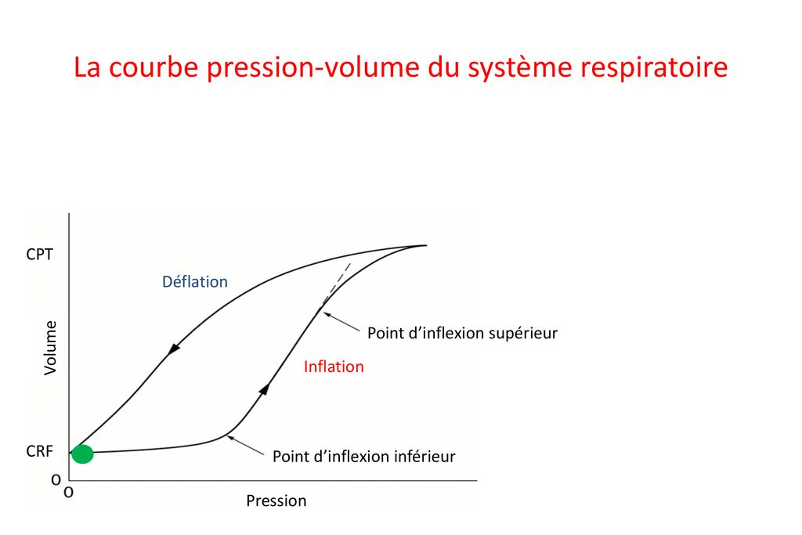

When the lung inflates during inspiration, it follows a different curve than when it deflates during expiration; this is called hysteresis .
At moderate pressures, lung compliance is greater. The lungs expand more easily. At high pressures, lung compliance is lower. The lungs expand less easily, and the curve flattens out.

4.2. Compliance of the lung-thoracic cage system

At rest, all respiratory muscles are relaxed , lung volume is at functional residual capacity (FRC) , and alveolar pressure equals atmospheric pressure. Under these equilibrium conditions, the lungs tend to collapse, but this tendency is precisely balanced by the tendency of the rib cage to expand. As a consequence of the opposition of these two trends, intrapleural pressure is lower than atmospheric pressure, therefore negative.

If air is introduced into the intrapleural space (pneumothorax), the intrapleural pressure becomes equal to atmospheric pressure. The lung collapses (its natural tendency) and the rib cage expands outwards (its natural tendency).

The figure below shows the pressure-volume relationship for the lung alone, the rib cage alone, and the lung-rib cage assembly.
The compliance of the lung-thoracic cage system is lower than that of the lungs alone or of the rib cage alone.
In emphysema, lung compliance increases (due to a decrease in elastic fibers) and the tendency of the lungs to collapse decreases. Thus, at the initial functional residual capacity (FRC), the tendency of the lungs to collapse is much weaker than the tendency of the rib cage to expand. The lung-rib cage system will seek a new and stronger FRC so that the two forces can balance. The patient's rib cage takes on a barrel shape. to adopt this new volume.
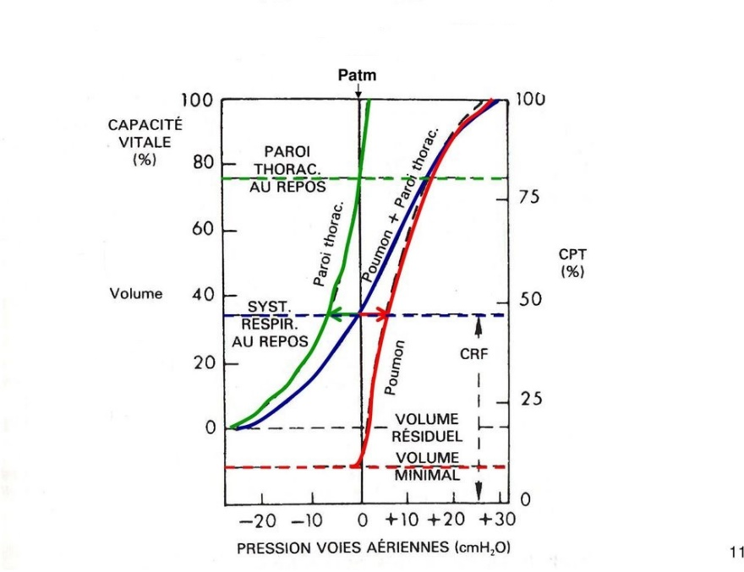

4.3. Surface tension of alveoli and surfactant
4.3.1. Surface tension of the cells
It results from the forces existing between the molecules of the liquid lining the alveoli. Due to their surface tension, the alveoli tend to collapse. The tendency of the pressure to collapse the alveoli is directly proportional to the surface tension and inversely proportional to the alveolar radius (Laplace's law), as shown by the following equation:

P = 2T/r
P : cell collapse pressure or pressure required to keep the cell open
T : surface tension
r : alveolar radius

Large alveoli (large radius) collapse at lower pressures and are easier to keep open. Small alveoli (small radius) collapse at higher pressures and are more difficult to keep open. In the absence of surfactant, small alveoli tend to collapse (atelectasis).

4.3.2. Surfactant
the alveolar epithelium. It lines the alveoli and reduces surface tension. It is produced by type II alveolar cells ( type II pneumocytes ) and consists primarily of a lipid, dipalmitoylphosphatidylcholine. Surfactant reduces surface tension. This reduction protects the small alveoli from collapse and increases compliance .

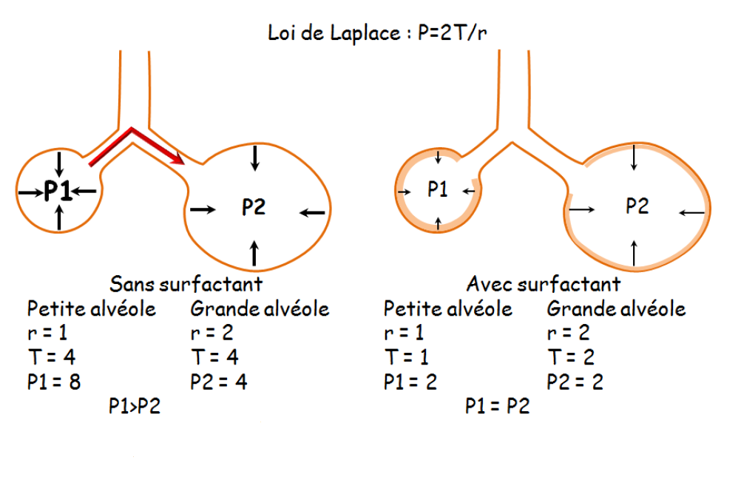

In the fetus, surfactant synthesis is variable. It can be found as early as the 24th ^{week} and is still present at the 35th ^{week} of gestation.
Neonatal respiratory distress syndrome can be observed in premature infants due to a lack of surfactant. The infant exhibits atelectasis during expiration, difficulty in reinflating their lungs (a consequence of decreased compliance ), and hypoxemia resulting from an inadequate ventilation/perfusion ratio.

4.4. Airway resistance
Airflow is directly proportional to the pressure difference between the mouth (atmospheric pressure) and the alveoli. It is inversely proportional to the airway resistance. Thus, the greater the resistance, the weaker the airflow.

Q = ΔP/R
Q: Air flow rate in mL /min or L/min
P: pressure gradient mm Hg
R: airway resistance cm H ₂ O/L/S

The resistance of the airways is described by Poiseuille's law, as shown in the following equation:

$$R=\frac{ 8 . l . η}{π . r4}$$
R: resistance
$η:$viscosity of the inspired gas
l : length of the airways
r : radius of the airways

Note the powerful inverse relationship between the resistance and the size (radius) of the airways.
Example : if the radius of the airways decreases by a factor of 2, the resistance is multiplied by a factor of 16 (2) and the airflow decreases enormously, by a factor of 16.

4.4.1. Factors modifying airway resistance
- The contraction or relaxation of bronchial smooth muscles modifies the radius of the airways:
Stimulation by the parasympathetic autonomic nervous system, an irritant, or a slow-reacting substance of anaphylaxis (asthma) causes constriction of the airways, decreases their radius, and increases resistance to airflow.
Sympathetic stimulation and sympathetic agonists ( isoprotenol ) dilate the airways, increase their radius, and decrease resistance to airflow via β2 receptors .
- Lung volume affects airway resistance due to the radial traction exerted on the airways by the lung tissue that surrounds them:
Low lung volumes are associated with lower traction and higher resistance of the airways, which can lead to airway collapse.
Large lung volumes are associated with stronger traction and lower airway resistance.
Patients with increased airway resistance (for example, asthmatics) learn to breathe with a lung volume more important to compensate for this strong resistance.

-The viscosity or density of the inhaled gas changes the resistance to airflow. During deep-sea diving, the density and resistance to flow of the air increases. However, breathing a low-density gas like helium reduces flow resistance air.

-Areas of resistance to airflow
The main area of airway resistance is located in the medium-sized bronchi. One might think that the smallest airways offer the greatest resistance, but this is not the case because of their parallel arrangement.

4.5. Respiratory cycle

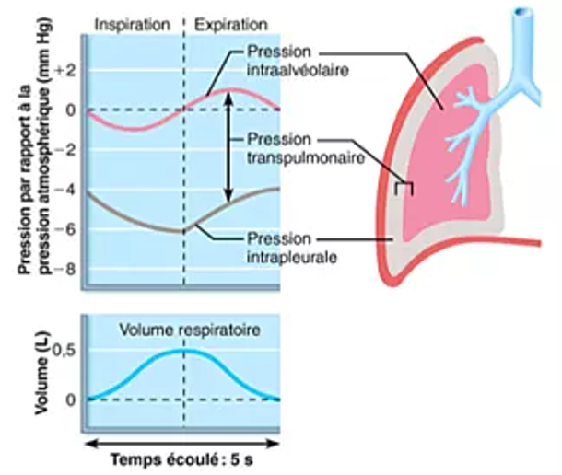

At rest (between two breathing movements)
Alveolar pressure is equal to atmospheric pressure, because pressures in the lung are always measured from atmospheric pressure, alveolar pressure is said to be equal to zero.
Intrapleural pressure is negative : the opposing forces of the lungs, which tend to collapse, and the rib cage, which tends to expand, create negative pressure in the intrapleural space that separates them. Lung volume is called FRC.

During inspiration
The inspiratory muscles contract, causing the chest to expand. As the chest expands, the alveolar pressure drops below atmospheric pressure (becoming negative). This pressure gradient forces air into the lungs. This flow continues until the pressure gradient between the atmosphere and the alveoli equalizes.
As lung volume increases during inspiration, the elastic force The withdrawal force exerted on the lungs increases. Intrapleural pressure becomes even more more negative than it was at rest. Negative airway pressure contributes to exaggerate the negativity of intrapleural pressure . Changes in intrapleural pressure during inspiration are used to measure dynamic compliance​ lungs.
The volume of the lung increases by a tidal volume. Thus, at the end of inspiration, the volume of the lung is equal to the sum of the FRC and the tidal volume.

During expiration
atmospheric pressure because the alveolar gas is compressed by the elastic forces of the lung. The pressure gradient is now reversed, and air flows out of the lungs.
Intrapleural pressure returns to its resting value during a normal (passive) expiration. During a forced expiration, intrapleural pressure becomes positive. This positive intrapleural pressure compresses the airways and makes expiration more difficult.
In chronic obstructive pulmonary disease (COPD), where there is increased airway resistance, patients learn to exhale slowly, with a puckering motion, to prevent airway collapse that would result from a forced exhalation. Lung volume returns to functional residual capacity (FRC) before another cycle begins.

5. Alveolar-capillary diffusion (hematosis)
This is the diffusion of oxygen from the alveolar air into the blood and the diffusion of carbon dioxide from the blood into the alveolar air across the alveolo-capillary membrane. The driving force of diffusion is the gas pressure gradient across the alveolar-capillary membrane. The diffusion of O2 _{and CO2} across the alveolar-capillary membrane is influenced by the following factors:
- The structural characteristics of the alveolo-capillary membrane.
- The relationship between alveolar ventilation and blood perfusion in the alveolar capillaries .
- Partial pressure gradients and gas solubilities.

5.1. Characteristics of the alveolo-capillary membrane
Alveolar-capillary diffusion depends on the surface area available for gas exchange. It is proportional to the exchange surface area, decreases when this surface area is reduced (e.g., in pulmonary emphysema), and is inversely proportional to the thickness of the exchange membrane. The thickness of the alveolar-capillary barrier influences the rate of diffusion (e.g., interstitial edema).

5.2. Ventilation-perfusion ratio
For gas exchange to be as efficient as possible, this correlation must constantly exist. Self-regulating mechanisms continuously adapt the conditions within the alveoli, specifically in alveoli where ventilation is inadequate.
In the alveoli where ventilation is insufficient, the pulmonary arterioles contract, this is hypoxic vasoconstriction and the blood is diverted to the parts where PO2 _{is} high and oxygen uptake can be carried out more efficiently .
In the alveoli where ventilation is maximal, the pulmonary arterioles dilate, and blood flow increases in the corresponding alveolar capillaries.
While variations in PO2 _{in} the alveoli affect the diameter of blood vessels (pulmonary arterioles), variations in PCO2 _{in} the alveoli modify the diameter of bronchioles.
The bronchioles serving regions where the alveolar concentration of carbon dioxide is high dilate, allowing CO2 _{to} be eliminated rapidly. Conversely, the bronchioles serving regions where the PCO2 _{is} low constrict.
Changes in the diameter of bronchioles and arterioles ensure that alveolar ventilation and pulmonary perfusion are always synchronized. Insufficient alveolar ventilation decreases the oxygen concentration and increases the carbon dioxide concentration in the alveoli. Consequently, the pulmonary arterioles constrict and the airways dilate, thus promoting synchronization between air and blood flow. The increase in PO2 _{and} the decrease in PCO2 _{in} the alveoli cause bronchioles to constrict and promote blood flow into the alveolar capillaries.
5.3. Partial pressure gradients and gas solubilities :
_{The} diffusion of O2 _{and} CO2 depends on differences in partial pressure on either side of the membrane. The diffusion of O2 _{from} alveolar air to pulmonary capillary blood depends on the difference in partial pressure of O2 _{across} the pulmonary capillaries. Normally, capillary blood reaches equilibrium with alveolar gas. When the partial pressures of O2 _{become} equal, there is no longer any net diffusion of _{O2} .

5.3.1. Dalton's Law and Partial Pressures
Dalton's law of partial pressures can be expressed by the following equation:
Partial pressure = total pressure x fractional concentration

In dry inspired air, the partial pressure of O2 _{can} be calculated as follows. It is assumed that the total pressure is equal to atmospheric pressure and that the fractional concentration of O2 _{is} 0.21.
PO2 ₌ 760 mm Hg x 0.21
= 160 mm Hg
In humidified tracheal air at 37°C , the calculation is modified to take into account the partial pressure of H2O _{at} 47 mm Hg.
_{Total} W = 760 mm Hg - 47 mm Hg
= 713 mm Hg
PO2 = 713 _{mmHg} x 0.21
= 150 mm Hg

Gas | Dry inspired air | Humidified tracheal air | Alveolar air | Systemic arterial blood | mixed venous blood
PO ₂ | 160 | 150  Addition of H2O , decrease in PO2 | 100  O2 diffuses from the alveolar air into the pulmonary capillary blood, thus lowering the _{alveolar} PO2 . | 100  The blood equilibrates with the alveolar air; it is reoxygenated. | 40  O2 diffuses from arterial blood into the tissues, thus decreasing the PO2 _{of venous} blood.
PCO2​ | 0 | 0 | 40  CO2 is added to the alveolar air from the _{blood} | 40  The blood balances with the alveolar air. | 46  CO2 diffuses from tissues into venous blood, increasing the PCO2 _{of venous} blood.

Noticed :
Approximately 2% of systematic cardiac output (bronchial and coronary flow) bypasses the pulmonary circulation: physiological shunt . The resulting influx of venous blood into the oxygenated arterial blood makes the PO2 _{of} arterial blood slightly lower than that of alveolar air.

5.3.2. Dissolved gases
The amount of gas dissolved in a solution (such as blood) is proportional to its partial pressure. The units of concentration for a dissolved gas are ml of gas/100 ml of blood.
_{'s} take O2 as an example:
[O2] = PO2 _{x} solubility of O2 _{in} blood
= 100 mm Hg x 0.03 ml O ₂ /l/mm Hg
= 0.3 ml O2 / 100 ml of blood

5.3.3. Limitation of gas exchange by perfusion and diffusion
- Exchanges limited by the infusion
When the gas reaches equilibrium At the beginning of the pulmonary capillary pathway, the partial pressure of arterial blood becomes equal to the partial pressure of alveolar air. Thus, gas diffusion can increase when blood flow increases.

- Exchanges limited by diffusion
When the gas does not reach equilibrium completely before the blood reaches the end of the pulmonary capillary, the partial pressure in the blood is less than that of alveolar air.

The diffusion of O2 _{from} alveolar air to pulmonary capillary blood is, most of the time, limited by perfusion, but becomes limited by diffusion in the case of disease.
In cases of fibrosis , the diffusion of O2 _{is} reduced due to the thickening of the alveolar membrane and the increase in diffusion distance.
In cases of emphysema, the diffusion of O2 _{is} reduced because the diffusion surface is reduced (there are not enough alveoli).

6. Transport of respiratory gases
_{O2} transport protein , but it also transports CO2 _{and} constitutes an important blood buffer.
Hemoglobin is a globular protein made up of four subunits . Each subunit has a heme half. which is a porphyrin containing iron. Iron is in the ferrous state (Fe ⁺ ² ), which binds O2. If iron is in the ferric state (Fe ⁺ ³ ), methemoglobin is present. who does not fix O2.
Each subunit has a polypeptide chain. Two subunits have α chains and two subunits have β chains: normal adult hemoglobin is, therefore, said to be α2β2.

Remarks :
In fetal hemoglobin, the B chains are replaced by γ chains. The affinity for O2 of fetal hemoglobin is greater than the affinity for O2 of adult hemoglobin, because the avidity for 2,3-diphosphoglycerate (2,3-DPG) is less.
Because the affinity of fetal hemoglobin for O2 is greater than the affinity for
1' O2 from adult hemoglobin, the movement of O2 from the mother to the fetus is facilitated.

2,3-DPG is an important metabolic intermediate in glycolysis . It plays a role in regulating oxygen transport in the blood by stabilizing hemoglobin . This stabilization reduces hemoglobin's affinity for oxygen, allowing its release at the tissue level.

-The blood's capacity to carry O2 is determined by the concentration of hemoglobin in the blood, it limits the amount of O2 that can be transported by the blood.
-The blood O2 content is the amount of O2 transported by the blood. It depends on the concentration of hemoglobin, the PO2 and the P50 of hemoglobin.

6.1. O2 _{Transport}
O2 is transported by the _{blood} in two forms: either dissolved or bound to hemoglobin.
Hemoglobin, at normal concentration, increases the blood's capacity to transport O2 by 70 times .
6.1.1. The hemoglobin-O2 dissociation _{curve}
Hemoglobin combines rapidly and reversibly with O2 _{to} form oxyhemoglobin. The hemoglobin-O2 dissociation curve is a graph showing the percentage of hemoglobin saturation as a function of _{PO2} .

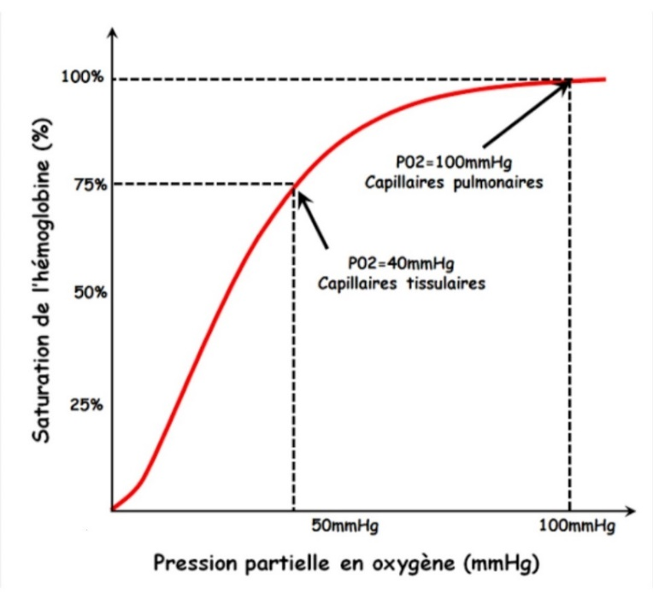
At a PO2 of 100 mm Hg (arterial blood)
Hemoglobin is always 100% saturated; O2 is bound to the four heme groups on all hemoglobin molecules.
At a PO2 of 40 mm Hg (mixed venous blood)
Hemoglobin is 75% saturated , which means that, on average, three of the four heme groups in each hemoglobin molecule have bound O2.
At a PO2 of 25 mm Hg
Hemoglobin is only 50% saturated. PO2 at 50% The saturation point is P50. 50% saturation means that, in On average, two of the four heme groups in each hemoglobin molecule have bound O2.
The sigmoid shape the curve is the result of a change in hemoglobin affinity each time an additional O2 molecule binds to a heme site. The binding of the first O2 molecule increases the affinity for the second O2 molecule, and so on. The highest affinity is for the fourth O2 molecule.
This change in affinity facilitates the loading of O2 by hemoglobin in the lungs.
(Flat portion of the curve) and the unloading of O2 towards the tissues (steep slope portion of the curve).

In the lungs, alveolar gas has a PO2 of 100 mm Hg. Pulmonary capillary blood is arteriolated by the diffusion of O2 from alveolar gas into the blood, so that the PO2 stabilizes at 100 mm Hg.
The very high affinity of hemoglobin for O2 in this pressure range facilitates the diffusion process by strongly binding O2 so that the partial pressure gradient that causes gas diffusion is maintained.
Since the curve remains flat for PO2 levels between 60 mm Hg and 100 mm Hg , humans can tolerate changes in atmospheric pressure (and PO2) without compromise the ability of hemoglobin to load _{O2} .

In peripheral tissues, O2 diffuses from arterial blood into cells. The O2 diffusion gradient is maintained because cells consume O2 for aerobic metabolism, keeping their PO2 low.
The lower affinity of hemoglobin for O2 in the steepest portion of the curve facilitates the unloading of O2 to the tissues.
6.1.2. Changes in the hemoglobin-O2 dissociation curve
- Movements to the right
They occur when the affinity of hemoglobin for O2 _{is} lowered. The P50 is increased and the unloading of O2 from arterial blood to the tissues is facilitated. For all PO2 values, the percentage of hemoglobin saturation is decreased.

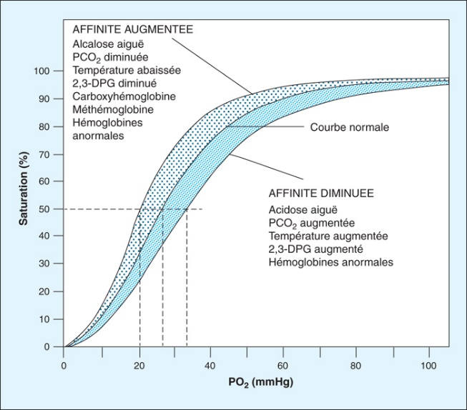

The increase in PCO2 or the decrease in pH
Shifting the curve to the right decreases hemoglobin's affinity for O2, thereby facilitating the delivery of O2 to the tissues (Bohr effect). During exercise, tissues produce more CO2, which lowers tissue pH and, due to the Bohr effect, facilitates the delivery of O2 to the working muscles.

The increase in temperature (for example, during exercise)
Shift the curve to the right. Shifting it to the right decreases hemoglobin's affinity for O2 and facilitates the delivery of O2 to tissues during these times of high demand.

The increase in the concentration of 2,3-DPG
It shifts the curve to the right by binding to the B chains of deoxyhemoglobin and lowers the affinity for O2.
Adaptation to chronic hypoxemia (e.g., adaptation to life at high altitude) results in increased synthesis of 2,3-DPG which binds to hemoglobin to facilitate the unloading of O2 to the tissues.
- Movements to the left
These events occur when the affinity of hemoglobin for O2 is increased. The P50 is decreased, and the unloading of O2 from arterial blood to tissues becomes more difficult. For any given PO2 value, the percentage of hemoglobin saturation is increased.
The causes of a leftward shift are inverses of those that cause a shift to the right: decreased PCO2, increased pH, lowered temperature and decreased 2,3-DPG concentration.

Noticed
Fetal hemoglobin (hemoglobin F) does not bind 2,3-DPG as strongly as adult hemoglobin. The affinity of fetal hemoglobin for O2 is increased, the P50 is decreased, and the curve is shifted to the left.

Carbon monoxide poisoning
There is competition between carbon monoxide (CO) and oxygen (O2) for binding sites on hemoglobin. Hemoglobin's affinity for carbon monoxide is higher than its affinity for O2. The hemoglobin-O dissociation curve is shifted to the left, indicating a greater affinity for the remaining O2 binding sites and, therefore, a reduced capacity to deliver O2 to the tissues. The total blood O2 content is decreased because the ability of hemoglobin to bind O2 is compromised by carbon monoxide.

_{CO2} Transport
CO2 is _{produced} in the tissues and transported to the lungs by venous blood in three ways:
- _{Dissolved} CO2 (in small quantities)
- In the form of carbaminohemoglobin (in small quantities)
- HCO3 (from the hydration of CO2 in the red blood cells) (90%) .

_{CO2} Transport in the form of ^{HCO3-} ₃
CO2 is produced in tissues and diffuses freely into the _{venous plasma, then into} the red blood cells. In the red blood cells, CO2 combines with H2O _{to} form H2CO3 , _{the} reaction being catalyzed by carbonic anhydrase . H2CO3 _{dissociates} into _{H} ⁺ and HCO3- .
HCO3 leaves _{red} blood cells in exchange for Cl- (displacement of chlorides) and is transported to the lungs in the plasma. HCO3 is the most important form of CO2 transport to the lungs.
The H+ ion is buffered inside red blood cells by deoxyhemoglobin . Because the
Deoxyhemoglobin is a better buffer for H+ than oxyhemoglobin ; it is preferable that the hemoglobin has been deoxygenated by the time the blood reaches the venous end of the capillaries where CO2 is added.
In the lungs, All the previous reactions occur in reverse order. HCO3 enters red blood cells in exchange for Cl-. HCO3 recombines with H+ to form H2CO3, which decomposes into CO2 _{and} H2O . The CO2 , initially produced in the tissues and transported to the lungs as HCO3, is exhaled.

7. Cellular Respiration
The supply of oxygen _{from} the blood to peripheral tissues, as well as the removal of carbon dioxide, _{occurs} by diffusion. Because carbon dioxide _{diffuses} much more easily, the diffusion of oxygen _{is} limited. This is made possible by the high density of capillaries, which constitute a large exchange surface area with short diffusion paths (maximum, approximately 10 to 25 µm).
The driving force is the difference in partial pressure of O2 ₍ ΔPO2 ₎ between the capillary blood and the O2-consuming mitochondria . Because PO2 _{decreases} along the capillaries, the cells at the venous end furthest from the capillary are the least supplied with O2 and are the first to be threatened by O2 deprivation .

8. Pulmonary circulation
Pressures in the pulmonary circulation are much lower than in the systemic circulation . Resistance is also much lower in the pulmonary circulation than in the systemic circulation, and cardiac output is equal to the cardiac output through the systemic circulation.
The low pressure of the pulmonary circulation is sufficient to propel these large cardiac outputs because pulmonary resistance is proportionally low.

8.1. Distribution of pulmonary blood flow
Blood flow distribution in the lungs is uneven, and this heterogeneity is explained by the effects of gravity . When a person is lying down , blood flow is almost uniform throughout the lung. However, when a person is standing, blood flow is lower at the top of the lung (zone 1) and higher at the base of the lung (zone 3).

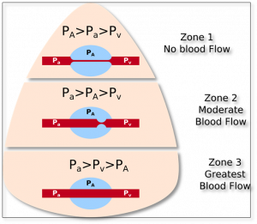

Zone 1: blood flow is lowest
Alveolar pressure > arterial pressure > venous pressure.
High alveolar pressure collapses the capillaries and reduces blood flow. This can occur when arterial blood pressure drops following a hemorrhage or when alveolar pressure increases due to positive pressure ventilation .

Zone 2: Blood flow is average
Blood pressure > alveolar pressure > venous pressure .
As blood moves down the lung, arterial pressure gradually increases due to the effect of gravity on hydrostatic pressure. Here, arterial pressure is greater than alveolar pressure, and blood flow is propelled by the difference between arterial and alveolar pressures. The alveolus compresses the venous end of the capillary bed.

Zone 3 : blood flow is highest.
Blood pressure > venous pressure > alveolar pressure.
As blood moves towards the base of the lung, arterial pressure is highest due to gravity, and venous pressure eventually increases until it exceeds alveolar pressure. The alveolus does not compress the capillary bed.
Blood flow is therefore due to the difference between arterial and venous pressures.

8.2. Regulation of pulmonary blood flow: hypoxic vasoconstriction
Hypoxia causes local vasoconstriction. This response is the opposite of that which occurs in the systemic circulation, where hypoxia leads to vasodilation. From a physiological perspective, this effect is important because local vasoconstriction diverts blood away from poorly ventilated and hypoxic areas of the lung (for example, after bronchial obstruction) and directs it toward well-ventilated areas.
Fetal pulmonary vascular resistance is very high due to generalized hypoxic vasoconstriction. Consequently, blood flow through the fetal lungs is low. With the first breath, the infant's alveoli become better oxygenated, pulmonary vascular resistance decreases, and blood flow in the lungs equalizes cardiac output (as is the case in adults).

8.3. Changes in the ventilation/perfusion ratio (V/Q)
This is the ratio of alveolar ventilation (V) to pulmonary blood flow (Q). Adapting ventilation and perfusion is important to achieve ideal O2 and CO2 exchange.

8.3.1. Normal V/Q Ratio
When the rate, tidal volume and pulmonary cardiac output are normal, the V/Q ratio is approximately 0.8. This leads to a value of 100 mm Hg for arterial PO2 and 40 mm Hg for arterial _{PCO2} .

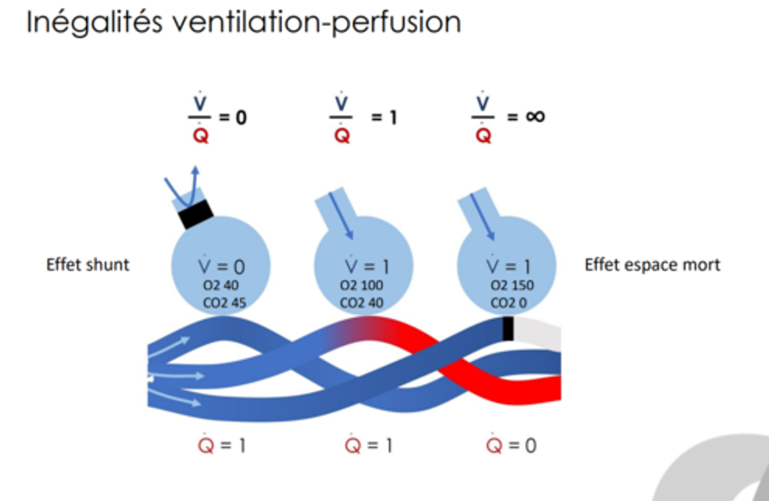

8.3.2. V/Q Ratio in case of airway obstruction
If the airways are completely blocked, then ventilation is zero. If blood flow is normal, then V/Q is zero. There is no exchange of gas in a lung that is perfused but not ventilated, PO2 and PCO2 of pulmonary capillary blood (and therefore, of systemic arterial blood) are close to those of mixed venous blood.

8.3.3. V/Q ratio in case of cessation of blood flow
If blood flow to a lung is completely blocked (for example, by an occlusive embolism of a pulmonary artery), then blood flow to that lung is zero. If ventilation is normal, then the V/Q ratio is infinite.
There is no gas exchange In a lung that is ventilated but not perfused, PO2 and PCO2 of the alveolar gas will approach those of the inspired gas.

8.3.4. V/Q ratios in different parts of the lung
Ventilation and blood flow are not distributed uniformly in the lung
normal . Blood flow is weakest at the apex and strongest at the base. Ventilation is also weakest at the apex and strongest at the base, but the regional differences for ventilation are not as great as for perfusion.
Therefore, the V/Q ratio is highest (greater than 1.0) at the apex of the lung and lowest (less than 0.8) at the base of the lung.
As a consequence of regional differences in the V/Q ratio , there are corresponding differences in alveolar and pulmonary capillary PO2 and PCO2. Regional differences in PO2 are greater than those in PCO2.
- At the peak (highest V/Q ratio), PO2 is highest and PCO2 is lowest.
- HAS at the base (lowest V/Q ratio), PO2 is lowest and PCO2 is highest.
- When the lungs are diseased , the V/Q ratio can be more pronounced than in a normal lung. This can lead to severe hypoxemia and mild hypercapnia.

9. Shunts (derivatives)
- Right-to-left shunts
They normally occur on a small scale, since 2% of cardiac output bypasses the lungs. They always result in a decrease in arterial _{PO2.} due to the admission of venous blood into arterial blood. They can account for up to 50% of cardiac output in certain congenital anomalies.

- Left-to-right shunts
They are much less common than right-to-left shunts. They are usually the result of congenital anomalies (for example, patent ductus arteriosus) or traumatic injury,
They do not result in a decrease in arterial PO2. On the contrary, PO2 rises on the right side of the heart because arterial blood has entered the venous blood.

10. Ventilation control
The ventilation control system is highly complex; it is capable of modifying ventilation according to metabolic needs, keeping arterial blood gases within narrow limits under most physiological circumstances.
The regulation of respiration is primarily controlled by the brainstem. Sensory information (PCO2 , lung expansion, irritation, muscle spindle, tendons, and joints) is coordinated in the brainstem. The motor response from the brainstem controls the respiratory muscles and the respiratory cycle .
10.1. Central control of ventilation (brainstem and cortex)
10.1.1. Dorsal respiratory group
It is a network of neurons located on the ventral portion of the brainstem, extending from the spinal cord to the junction of the medulla oblongata and the pons . It appears to be a center for generating and integrating respiratory rhythms. It is primarily responsible for inspiration and establishes the basal rate of ventilation.
Influxes The signals reach the dorsal respiratory group via the vagus and glossopharyngeal nerves. The vagus nerve relays information from peripheral and pulmonary mechanical chemoreceptors. The glossopharyngeal nerve relays information from peripheral chemoreceptors. Projections from the dorsal respiratory group are made, via the phrenic nerve, to the diaphragm.
10.1.2. Ventral respiratory group
It is primarily responsible for exhalation; it is inactive during normal, quiet breathing, as long as exhalation is passive. It becomes active during exercise, when exhalation becomes an active process.

10.1.3. Apneustic Center
It is located in the inferior annular protuberance; it stimulates inspiration. producing a sudden inspiratory movement ( gasp ) deep and more prolonged ( freediving ).

10.1.4. Pneumotaxic Center
It is located in the superior annular protuberance . It inhibits inspiration and thus regulates inspiratory volume and expiratory speed.
It accelerates the respiratory rate in response to emotion and fever, and it also modulates ventilatory adaptation to variations in PO2 and PCO2.
It regulates the activity of the respiratory center and coordinates it in particular with thermoregulation (dog).
10.1.5. Cerebral Cortex
Ventilation can be controlled by will. Thus, a person can voluntarily
Hyperventilation or hypoventilation . Hypoventilation (retained ventilation) is limited by an increase in PCO2 and a decrease in PO2. A prior phase of hyperventilation prolongs the duration of the respiratory retention period .

10.2. Chemoreceptors for CO2 , H ⁺ _{and} O2
10.2.1. Central chemoreceptors
They are located on the ventral surface of the medulla oblongata, near the exit of the 9th and 10th cranial nerves. They are sensitive to the pH of the cerebrospinal fluid (CSF). H+ does not cross the blood-brain barrier as CO2 does. CO2 diffuses from arterial blood into the CSF because it is lipid-soluble and readily crosses the blood-brain barrier. In the CSF, CO2 combines with H2O to produce H+ and HCO3. The resulting H+ acts directly on central chemoreceptors. Thus, an increase in PCO2 and H+ stimulates ventilation, and a decrease in PCO2 and H+ inhibits respiration.
The resulting hyperventilation or hypoventilation brings arterial PCO2 back to its normal value.

Noticed :
In chronic respiratory failure , if CO2 retention persists, _{HCO3-} ions are transported into the CSF where they buffer H+ ions, which limits reactive hyperventilation (absence of hyperventilation despite high PCO2).

10.2. 2. Peripheral carotid and aortic chemoreceptors
The carotid chemoreceptors are located at the bifurcation of the primitive carotid arteries.
Aortic chemoreceptors are located above and below the aortic arch.
Decreases in arterial PO2 They stimulate peripheral chemoreceptors and increase respiratory rate . The PO2 must fall to low values (<60 mmHg) before ventilation is stimulated. Below 60 mmHg, the respiratory rate is very sensitive to PO2.
Increases in arterial PCO2 stimulate peripheral chemoreceptors, increase respiratory rate and enhance the stimulation of ventilation caused by hypoxemia.
The response of peripheral chemoreceptors to CO2 is not as important as the response of central chemoreceptors to CO2 (H+).

Increases in arterial [H+] directly stimulate peripheral chemoreceptors in carotid bodies, independently changes in PCO2. Thus, in cases of metabolic acidosis, where [H+] is increased (pH lowered), the respiratory rate increase.

10.3. Other types of receivers for ventilation control
10.3.1. Lung stretch receptors
They are located in the smooth muscle of the airways (trachea and bronchi). When stimulated by lung distension during inspiration, they act on the respiratory center (via the vagus nerve) and cause inspiration to stop. During expiration, as the lung tissue contracts, sensory stimulation becomes less frequent, reaching its minimum at the end of expiration. At this point, the respiratory center triggers a new inspiration. This autoregulation via the vagus nerve constitutes the Hering -Breuer reflex .
10.3.2. Receptors of irritation
The lungs contain receptors located between the epithelial cells of the airways and react to a wide variety of irritants. Once activated, these receptors communicate with the respiratory centers via vagus nerve neurons.
In the bronchioles, accumulated mucus, dust, and harmful vapors stimulate receptors that cause a reflex constriction. The same irritants cause coughing when they lodge in the trachea and bronchi, and they trigger sneezing. if they are located in the nasal cavities.

10.3.3. J receptors ( juxtacapillary )
They are located in the alveolar walls near the capillaries. Congestion of the pulmonary capillaries, as can occur in left heart failure , stimulates J receptors, which lead to rapid, shallow ventilation.

10.3.4. Joint and muscle receptors
They are activated during limb movement, they are involved in the early stimulation of ventilation during exercise.

