RENAL PHYSIOLOGY

- Body fluids
- Functional anatomy of the kidney
- Glomerular filtration and its regulation
- Reabsorption and tubular secretion
- Sodium Regulation
- Potassium regulation
- Water balance
- Acid-base balance

1. Bodily fluids
The normal functioning and survival of the body's cells require two essential conditions. On the one hand, the production of metabolic energy and on the other hand, the volume and composition of intracellular fluid must remain relatively stable within fairly narrow physiological limits.

The stability of the body's hydro-electrolytic composition is the result of perfectly coordinated organ function and the continuous intervention of multiple regulatory mechanisms, correcting inevitable disturbances.

1.1. Total body water
Water is the main component of the human and animal body, representing approximately 60% of body weight. The body's water content varies depending on:
- Body fat
- Age plays a role: the older the tissues, the more dehydrated they become. This represents 75% of an infant's weight.
- Sex: 50% of a woman's weight
Two-thirds of this water is found within the cells and constitutes the intracellular water present in the intracellular compartment. The remainder of the water contained in the body corresponds to the extracellular water present in the extracellular compartment. The latter is subdivided into two sectors: the interstitial fluid and the plasma.
The body's water content is the result of a dynamic balance between intake (drinks, water contained in solid foods, water produced by cellular metabolism ) and losses (urine, feces, perspiration).

Body

Total Water Matter
Dry 40% of the body 60%

Liquid Liquid
Intracellular 40% Extracellular 20%

Plasma 5% Liquid
Interstitial 15%

1.2. Internal environment
The internal environment is composed of the different fluids of the body, namely: plasma, interstitial fluid and lymph.
The composition of the internal environment must allow each cell to obtain the elements it needs. Similarly, it is in the internal environment that the waste products of cellular activity are eliminated. The internal environment therefore constitutes a true living environment for cells. The internal environment (extracellular fluid) is the site of exchanges between cells and the external environment.

1.3. The different fluid compartments and their composition
1.3.1. The intracellular compartment
Bounded by the water-permeable plasma membrane, it comprises two-thirds of the body's total water and represents 40% of body weight. Intracellular fluid is not a single large compartment, but rather each cell is separated from the others by interstitial fluid. Its ionic composition is kept constant.

The main intracellular cations are:
- Na ⁺ = 10-15 mmol/L
- K ⁺ = 140 mmol/L
Intracellular Na and K concentrations are kept constant by the Na-K-ATPase pump.
The main intracellular anions are:
- Cl- ⁼ 2 mmol L
- HCO3- ₌ ⁸ mmol/L
1.3.2. The extracellular compartment
This is the water present outside the cells, represents 1/3 of the total body water and constitutes 20% of body weight.
The vascular wall in turn divides the extracellular fluid into two other compartments containing interstitial and plasma fluids .

1.3.2.1. The plasma compartment
Represented by plasma: the liquid fraction of blood, it is contained in the blood vessels and corresponds to 4% of body weight and ¼ of ECF.
Plasma contains in solution proteins (albumin, globulins), dissolved non-ionized substances (urea, glucose, organic acids) and completely dissociated electrolytes.
The main plasma ions are:
- K ⁺ = 4 mmol/L
- Na ⁺ = 142 mmol/L
- Cl- ⁼ 110 mmol/L
- HCO3- ₌ ²⁶ mmol/L

1.3.2.2. The interstitial compartment
This is the fluid that is in direct contact with the cells; it fills the space between the capillary membrane and the cell membrane. It represents 15% of body weight and ¾ of ECF.
The excess interstitial fluid is drained by the lymphatic capillaries where it takes the name lymph and is transported to the neck where it is reintegrated into the blood in the left subclavian vein via the thoracic duct.
The electrolyte composition of the interstitial fluid is very similar to that of plasma, except for the lower protein content of the interstitial fluid relative to plasma due to the impermeability of the vascular wall to large molecules. Thus, the interstitial fluid is an ultrafiltrate of the plasma. This difference in protein concentration results in a slight modification of the electrolyte distribution between these two compartments (Gibbs-Donnan equilibrium).

1.4. The Gibbs-Donnan equilibrium
When a solution containing only ions is separated from a solution of pure water, the electrochemical potentials are equal. However, if one of the compartments contains a charged protein, it tends to retain ions of opposite charge, thus creating unequal ionic concentrations between the compartments. This results in an equilibrium characterized by a non-zero membrane potential difference: this is the Gibbs-Donnan effect. At equilibrium, small ions cross the dialysis membrane. They are no longer at equal concentrations on both sides.
Although the concentrations are not equal, it is important to understand that the Gibbs-Donnan equilibrium obeys the laws of electroneutrality. Each of the solutions is electrically neutral.
1.5. Hydro-electrolytic solutions
A hydro-electrolytic solution is obtained by dissolving a substance called the solute in a liquid called the solvent.
An electrolyte solution is a solution containing ions. It conducts electricity and is electrically neutral. Ions, or electrolytes, make up approximately 95% of the solutes or particles found in bodily fluids.
Sodium and chloride are by far the most abundant ions in the extracellular fluid, while potassium and phosphate predominate in the intracellular compartment.
Despite the physiological importance of certain undissociated substances, such as glucose, urea, and some amino acids, these particles constitute only a small fraction of all solutes found in bodily fluids.

1.6. Units of measurement for solution concentrations
I.6.1. Molarity and molality
- Molarity is the concentration expressed in moles per liter of solution.
- Molality is the concentration expressed in moles per kg of water.

1.6.2. Osmolarity and osmolality
The osmolarity of a solution is the concentration, expressed as the number of moles, of osmotically active particles in 1 liter of solution.
Osmolality is the number of moles of particles in solution in 1 kg of water.
1 Osmole (Osm) corresponds to one mole of particles.
Plasma osmolarity is calculated as follows:
Plasma osmolarity = 2 × [Sodium] + [Azotemia] + [Glycememia]
Sodium level = 145 mmol/L
Glucose-related osmolarity = 5 mOsm/L for a blood glucose level of 1 g/L
Urea-related osmolarity = 5 mOsm/L for a urea level of 0.3 g/L
Plasma osmolarity = (2×145) + 5 + 5 = 300 mOsm/L
At equilibrium, there is almost equal osmolarity in all bodily fluids.

1.6.3. Electrochemical Equivalence
Used to express the concentration of solutes that dissociate into several particles once in solution.
The concentration of an electrolyte in equivalents per liter is equal to its valence (electrical charge) multiplied by its concentration in moles per liter.
EX :
Monovalent electrolytes: NaCl = Na ⁺ + Cl- ⁼ 2 Eq/L

Divalent electrolytes: CaCl₂ ₌ Ca²⁺ ⁺ 2Cl⁻ ⁼ 4 Eq/L

1.7.1. Osmosis and tonicity
1.7.1.1. Osmosis
The net diffusion of water across a semi-permeable membrane is called osmosis. Water moves down the concentration gradient from the less concentrated compartment to the more concentrated compartment.
1.7.1.2. Tonicity
Tonicity is defined in relation to a cell; it is the effect of the osmolarity of a solution on the cell volume.
– Cell volume unchanged _isotonic solution
– Reduced volume _ hypertonic solution
– Increased volume _ hypotonic solution

2. Dynamic aspects of body fluids: Exchanges between fluid compartments
Even though the volume and ionic composition of body fluids are kept relatively stable, this balance is dynamic and not static and reflects a continuous exchange of water and electrolytes across the biological membranes separating the various fluid compartments.
A normal cell volume is necessary for proper cell function and depends on the movement of water according to the osmotic gradient across the cell membrane.
Normal plasma and blood volume is essential for adequate tissue perfusion and depends on the movement of water and solutes across the capillary membrane into the interstitial compartment or out of the body.

The permeability of the cell membrane is very different from that of the capillary wall. The cell membrane is freely permeable to water but only to certain small solutes. The capillary endothelium, which is highly fenestrated, allows water and all small solutes to pass through, but not protein macromolecules.
Hydro-electrolytic transfers between the different fluid compartments of the body are governed by three forces:
- Osmotic pressure:
Osmotic pressure is the pressure exerted by particles in solution, and is responsible for osmosis.
Osmotic pressure is primarily developed by dissociated electrolytes.
Water transfers between fluid compartments are primarily governed by osmotic pressure gradients.
- Oncotic pressure
Pressure generated by large molecules, especially proteins in solution.
It is pressure that attracts water towards proteins; osmotic pressure attributable to proteins.
- Hydrostatic pressure
Generated by the cardiovascular system.

2.1. Exchanges between extracellular and intracellular compartments

2.1.1. Water exchanges
Cell membranes and capillary walls are highly permeable to water, which can therefore move easily from one compartment to another. However, plasma membrane (PM) is much more permeable to water than to solutes and is even impermeable to several of them.
The osmotic gradient created by solutes that do not cross the plasma membrane moves water between the two intracellular and extracellular compartments.
Water channels, or aquaporins, present in the cell membrane facilitate this movement of water.
Since the extracellular compartment is in contact with the external environment, any changes in volume and osmolarity that occur there result in changes in the volume and osmolarity of body fluids.
Any gain or loss of water or osmoles occurring in the extracellular compartment results in changes in plasma volume and osmolarity, and consequently a redistribution of water between the extracellular and intracellular compartments.
Osmotic balance requires that there be a near-equal osmolarity in all body fluids (except urine and sweat ) ~300 mosmoles/L

Examples of water and electrolyte movements between compartments
- Iso-osmotic volume expansion: isotonic NaCl perfusion
The volume of the ECF increases, but its osmolarity does not change. Since the osmolarity of the ECF has not changed, there will be no movement of water between the ICF and the ECF.
- Iso-osmotic contraction of volume: diarrhea
The volume of extracellular fluid decreases, but its osmolarity does not change.
Therefore, there will be no water movement between the LIC and the LEC.
- Hyperosmotic volume expansion: high NaCl ingestion
The osmolarity of the ECF increases due to the addition of NaCl osmoles.
Water migrates from the ILC to the ECL; following this water migration, the osmolarity of the ILC will increase until it equals that of the ECL.
As a result of the displacement of water out of the cells, the volume of the ECL increases and the volume of the ILC decreases.
- Hyperosmotic contraction of volume: diabetes insipidus
In this case, water loss is greater than salt loss, so the volume of the ECF will decrease due to water loss and its osmolarity will increase.
Water migrates from the ILC to the ECL. The osmolarity of the ILC will increase until it equals that of the ECL.
As a result of the displacement of water out of the cells, the volume of the LIC decreases.

- Hypo-osmotic volume expansion: pure water gain: SIADH (syndrome of inadequate ADH secretion (ADH: antidiuretic hormone))
The volume of the ECF increases and its osmolarity decreases due to the retention of excess water.
Water migrates from the ECF to the ICF; consequently, the volume of the ICF increases and its osmolarity decreases until it equals that of the ECF.
- Hypo-osmotic contraction of volume: renal failure
In this case, the loss of NaCl is greater than the loss of water.
The volume and osmolarity of the ECF decrease.
Water migrates into the cells.
As a result, the volume of the ILC increases and its osmolarity decreases.

2.1.2. Electrolyte exchange
Unlike water, electrolytes do not diffuse freely across the plasma membrane. Their transfer between the extracellular and intracellular compartments requires specific membrane transport proteins, such as the Na-K-ATPase pump and the Na ⁺ -H ^{+ exchanger} .

- Sodium and Potassium
Transmembrane diffusion of Na and K is primarily mediated by the Na-K-ATPase pump, whose essential function is to generate and maintain sodium and potassium concentration gradients between the extracellular and intracellular compartments. These gradients are physiologically crucial as they are necessary for maintaining membrane potential and cell volume.
Maintaining sodium in the extracellular compartment keeps the extracellular volume constant and thus prevents progressive cell swelling and bursting.
Maintaining potassium in the intracellular compartment The Ki/Ke ratio between intracellular and extracellular potassium concentrations remains constant. A normal value for this ratio ensures a resting membrane potential of around -90 mV. Depolarization of the cell membrane and the generation of an action potential of +20 mV cause muscle cells to contract and, in nerve cells, to be excited and then conduct the nerve impulse.

- Hydrogen cation
The Na-H exchanger is present in the membrane of many cells. The transport of a sodium ion from the extracellular fluid into the cell is coupled to the movement of a hydrogen ion in the opposite direction. Both sodium and hydrogen ions are transported down their concentration gradients.
The Na-H exchanger therefore plays an important role in maintaining the volume and acidity of extracellular and intracellular fluids.
- In the case of metabolic acidosis: [H+] in the ECF increases
⁺⁾ ions enter cells in exchange for sodium (Na+) or potassium (K+). The effect of Na+ efflux is negligible; however, significant K+ efflux leads to hyperkalemia.
- In the case of metabolic alkalosis: [H+] in the ECF decreases
⁺ ions leave the cells in exchange with Na+ and K+. The effect of Na+ influx is negligible, but the effect of a large K+ influx leads to hypokalemia .

2.2. Exchanges between the plasma and interstitial compartments

Four forces, described by Starling, govern the passive exchange of fluid across the capillary wall under physiological conditions. These pressures are responsible for the distribution of fluid between the plasma and interstitial compartments.
PNF = K _{f} × [(P _{C} -P _{I} )-( π _{C} - π _{I} )]
PNF: Net filtration pressure:
- If PNF is positive, there is a net movement of fluid out of the capillary: this is filtration.
- If PNF is negative, there is a net movement of fluid into the capillary: this is absorption.
K _{f} : The filtration coefficient:
This is the permeability of the capillary wall to water.
PC : _{Capillary} hydrostatic pressure: Promotes filtration out of the capillary.
It is determined by arterial and venous pressures and by resistances. It is higher at the arterial end of the capillary (25 mm Hg) than at the venous end (10 mm Hg).
Relaxation of the precapillary sphincter and an increase in postcapillary resistance raise hydrostatic pressure. A decrease in precapillary resistance and a drop in postcapillary resistance reduce this pressure.
PI : Interstitial hydrostatic pressure: Opposes filtration out of the capillary.
It is normally zero or slightly negative, around -3 mm Hg.
π _{C} : Capillary oncotic pressure:
It is 28 mm Hg and opposes filtration out of the capillary.
It increases with an increase in the level of proteins in the plasma.
π _{I} : Interstitial oncotic pressure: Promotes filtration out of the capillary.
It is approximately 8 mm Hg, resulting from small amounts of protein leaking from the vascular space and remaining inside the interstice.

In fact, the pressures are not identical in the arterial and venous parts of the capillary. On the arteriolar side, the differential hydrostatic pressure exceeds the differential oncotic pressure. This imbalance promotes the passage of water and dissolved substances from the plasma into the interstitial compartment.
Conversely, on the venous side, the differential hydrostatic pressure becomes lower than the differential oncotic pressure. This phenomenon then promotes the return of water and dissolved substances from the interstitial compartment to the plasma.

While water and salt retention increases plasma volume, the transfer of plasma fluid to the interstitial compartment helps maintain constant plasma and blood volumes. This expansion of the interstitial volume thus prevents a significant increase in plasma volume.
Conversely, if a loss of water and salt contracts the plasma volume, the transfer of interstitial fluid into the vascular space maintains plasma and blood volumes.
Interstitial fluid therefore acts as a reservoir, preventing a rise or fall too rapid in plasma volume.
RENAL PHYSIOLOGY
Introduction
The kidneys perform a multitude of bodily functions essential to the proper functioning of the organism and the survival of the animal. The popular view of the kidney is that it serves to eliminate metabolic waste from the body; this is indeed one of its functions, but it has other equally important functions such as the regulation of hydro-electrolytic balance, regulation of extracellular fluid volume and blood pressure, regulation of osmolarity (290 mOs/L), regulation of acid-base balance (plasma pH) and the production of hormones (erythropoietin, renin, Vitamin D) .
1. Functional anatomy of the kidney (see projection)
General organization of the kidney
The kidneys are part of the urinary system and are the site of urine production. They are retroperitoneal organs located in the lumbar region. In a longitudinal section of the kidney, starting from the concavity, we can distinguish:
The hilum : with the basilar ridge, the major calyces and the minor calyces
The medulla : the deepest red layer, mainly composed of radially striated medullary tissue containing:
- Malpighi pyramids: triangular formations with an external base.
- The pyramids of Ferrin: extensions located at the base of the pyramids of Malpighi .
- Bertin's columns are extensions of the cortical wall separating the Malpighi pyramids .
Cortical : containing three parts:
- Bertin's column : the deepest zone containing the nephrons and vascular elements
- Labyrinth: middle region outside the pyramids of Ferrein, has the same structure as the latter.
- Cortex corticis : the outermost region containing the tubular elements and vessels.
The connective tissue capsule : covering the kidney from the outside.

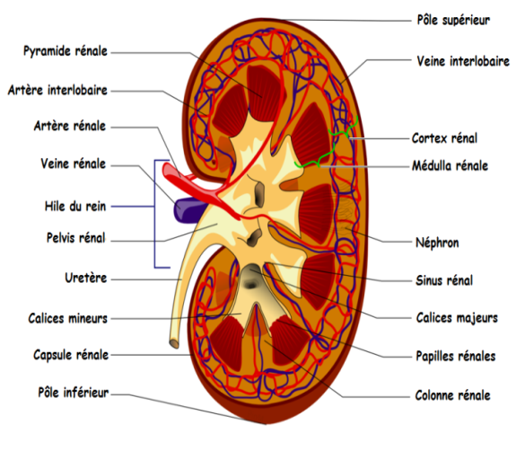
1.1. The nephron
The renal parenchyma is made up of a large number of basic functional units called nephrons (more than 1 million per kidney). The nephrons drain into the cribrous area via collecting tubules. The entire nephron and the system of collecting tubules into which it empties is referred to as the urinary tubule.
The nephron consists of two parts:
Malpighian corpuscle: spherical vascular formation
Renal tubule: composed of 3 successive elements:
- A proximal segment: the proximal convoluted tubule (PCT)
- A medium segment: Henle's Cove
- A distal segment: the distal convoluted tubule (DCT)
There are two types of nephrons: short nephrons, which make up 80 to 90%, are located in the superficial cortical region, and long nephrons, which make up 10 to 20% and are located in the deep zone of the cortical region known as juxtamedullary.
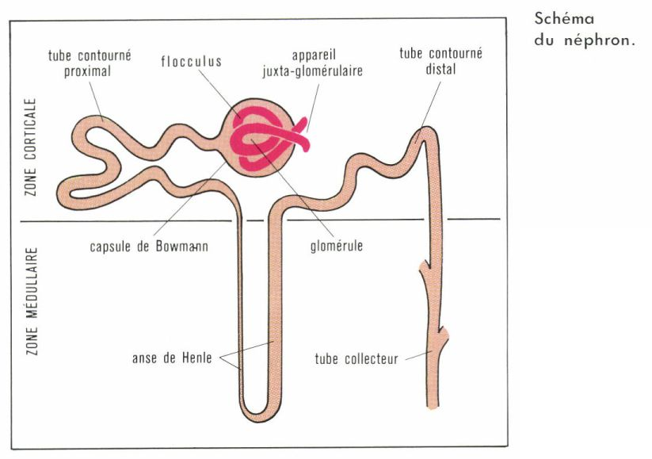
1.2. Malpighian corpuscle consisting of an arterial cluster called a glomerulus housed in an envelope called Bowman's capsule made up of two layers:
- parietal layer consisting of a simple squamous epithelium, resting on a basal lamina located towards the outside.
- visceral layer , lining the external face of the capillaries, consisting of a particular epithelial lining formed by podocytes characterized by the presence of pedicels .
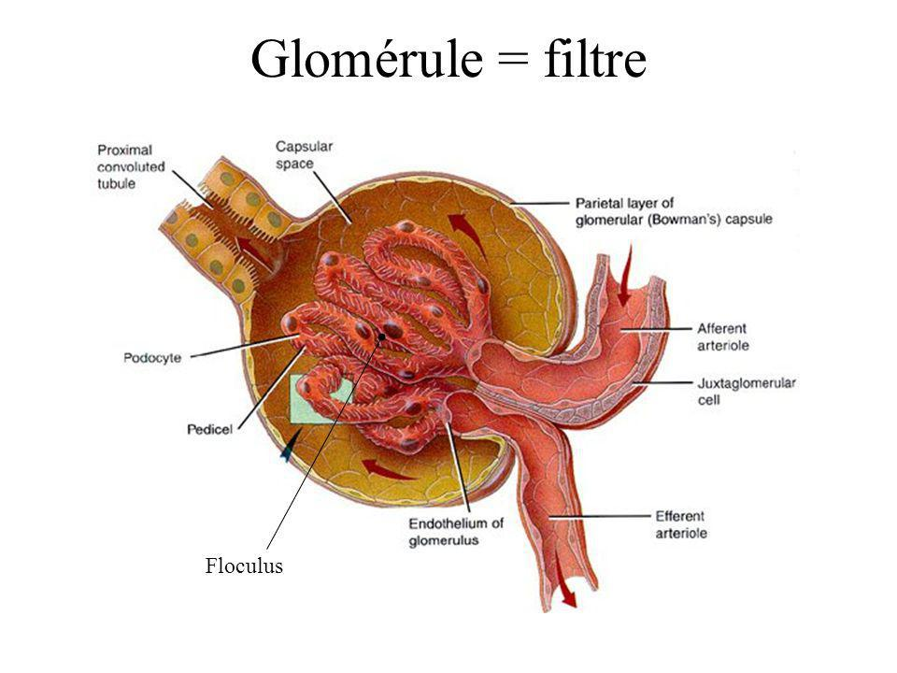
The space left free between these two layers forms the glomerular chamber .
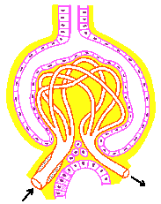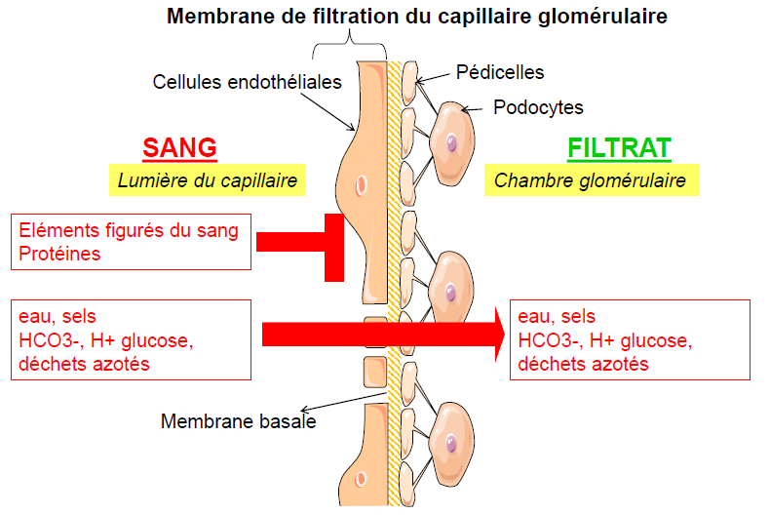

1.3. Juxtagomerular apparatus
The juxtaglomerular apparatus is a syncytium resulting from the contact of a glomerulus with a portion of the distal tubule, thus having both a vascular and a tubular component. The juxtaglomerular apparatus comprises three types of cells:
Juxtaglomerular cells are specialized smooth muscle cells located in the wall of the terminal portion of afferent glomerular arterioles and the initial portion of efferent arterioles and produce renin.
Mesangial cells.
The epithelial cells of the macula densa located in the wall of the tubule at the end of the thick ascending limb of the loop of Henle where it meets the glomerulus.

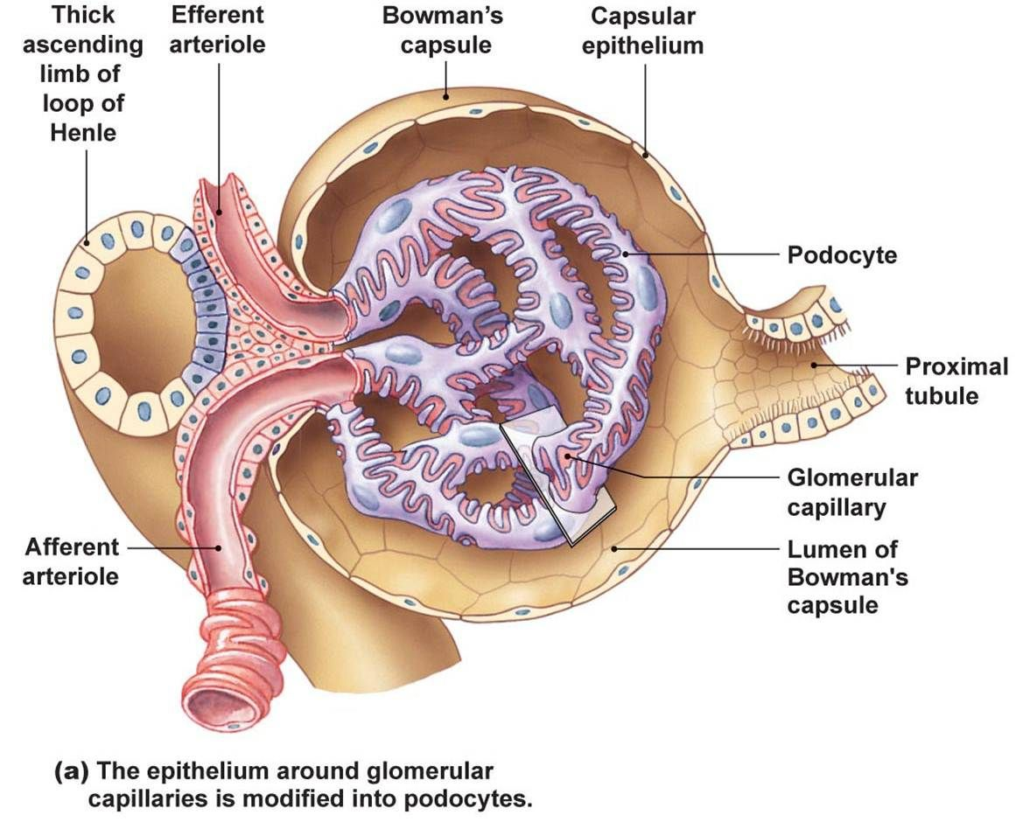
1.4. Kidney vascularization
The kidney's blood supply is provided by the renal artery which divides The anterior and posterior arteries give rise to the interlobar arteries , which run within the columns of Bertin. At the base of the renal pyramids (Malpighian pyramids), the interlobar arteries divide, forming the arcuate arteries , whose course is parallel to the surface of the kidney. The arcuate arteries give off collateral branches at right angles, which ascend in the cortex between the renal pyramids (Ferrin's pyramids). The collateral branches of the arcuate arteries are short; these are the afferent arteries of the glomeruli. Upon exiting the corpuscle, the efferent arteries of the glomerulus give rise to the peritubular capillary network. Vasa Recta
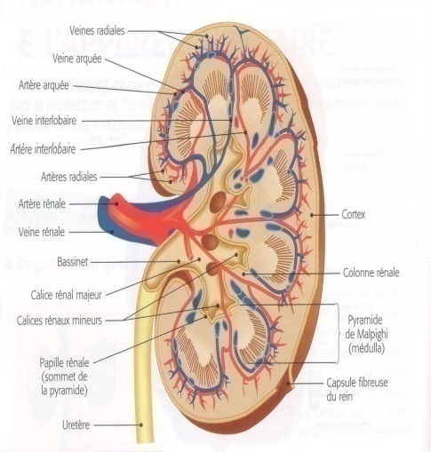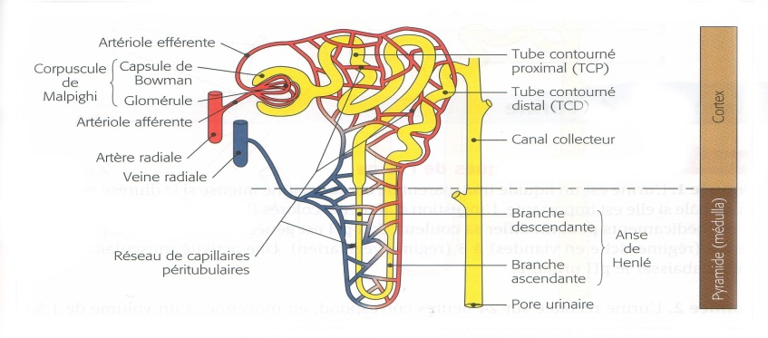

2. Kidney Functions
The three main functions of the nephron that participate in the formation of urine by the kidneys are:
- filtration of plasma from the glomerular capillaries into the tubular lumen;
- reabsorption of tubular fluid into the lumen of the peritubular capillaries;
- secretion of plasma from the peritubular capillaries into the tubular lumen.

2.1. Glomerular filtration:
Glomerular filtration occurs at the level of the Malpighian corpuscle. It is a unidirectional, passive, and non-selective process in which plasma is forced by the pressure within the glomerular capillaries toward Bowman's space through the filtration membrane. This ultrafiltration process takes place across a semi-permeable membrane that prevents the passage of blood cells and proteins. This ultrafiltrate is also called primary urine .
Noticed
Only one fifth (20%) of the plasma that passes through the kidneys filters inside the nephrons, the other four fifths (80%) remain with the proteins and blood cells and flow into the peritubular capillaries.
The filtered fluid from the capillary lumen into Bowman's urinary space passes through the filtration barrier made of three layers:
- The glomerular capillary endothelium: a capillary fenestrated by narrow pores to prevent the passage of blood cells, lined with negatively charged proteins that repel plasma proteins.
- The basement membrane: an acellular structure composed of collagen and other negatively charged glycoproteins
- Epithelium of Bowman's capsule: portion of the epithelium surrounding the glomerular capillaries composed of specialized cells called podocytes whose cell bodies protrude into the urinary chamber, the pedycels are arranged on the basement membrane so as to form filtration slits, which are closed by a very thin membrane called diaphragm or filtration membrane .

The volume of fluid that filters into the capsule per unit of time is called the glomerular filtration rate (GFR). The glomerular filtration rate is determined by Starling forces:
DFG= K _{f} × [(P _{CG} -P _{EB} )-(π _{CG} -π _{EB} )]
Filtration is always preferred.
K<sub> _{f</sub>} : The filtration coefficient of glomerular capillaries
PCG : Hydrostatic pressure in glomerular _{capillaries} : constant along the entire length of the capillary. It is increased by dilation of the afferent arteriole or by constriction of the efferent arteriole. An increase in PCG leads to an increase in GFR .
PE _{EB} : Hydrostatic pressure in Bowman's space: it increases due to constriction or blockage of the ureters. An increase in PE _{EB} causes a decrease in GFR
π _{CG} Glomerular capillary oncotic pressure increases along the glomerular capillary because water filtration increases the concentration of proteins in the glomerular capillaries. The increase in π _{CG} causes a decrease in GFR.
π _{EB} Oncotic pressure in Bowman space: generally zero

2.1.1. Regulation of the GFR
The GFR is not fixed; its regulation is ensured by several mechanisms .
Glomerular filtration is regulated primarily by changes in hydrostatic pressure within the glomerular capillaries. by modifying preglomerular and postglomerular resistance. The main sites of preglomerular and postglomerular resistance are the afferent and efferent arterioles, respectively. Vasoconstriction of afferent arterioles and vasodilation of efferent arterioles decrease hydrostatic pressure in the glomerular capillaries, filtration pressure, and glomerular filtration. Conversely , vasodilation of afferent arterioles and vasoconstriction of efferent arterioles increase all three parameters.

2.1.1.1. Intrinsic regulation of glomerular filtration
Autoregulation of the glomerular filtration rate (GFR) is possible thanks to intrinsic regulatory mechanisms by which the kidney continuously adjusts the GFR to maintain it constant at 125 ml/min despite variations in blood pressure. There are no variations in renal function (RFR) or GFR for mean arterial pressure variations ranging from 80 to 180 mmHg. These mechanisms are:
- Vascular myogenic mechanism
This reflects the tendency of vascular smooth muscle to contract in response to stretching. Stretching of the walls of afferent arterioles due to increased blood pressure causes vasoconstriction of the vascular smooth muscle. Vasoconstriction leads to a decrease in glomerular filtration rate (GFR). A decrease in blood pressure has the opposite effect.

- tubuloglomerular feedback control
It is a local regulatory loop involving the macula densa cells of the juxtaglomerular apparatus which are true osmoreceptors sensitive to the composition of the tubular fluid.
In response to changes in tubular NaCl concentration, the cells of the macula densa release a substance that acts on the smooth muscle of the neighboring afferent arteriole :
- An increase in GFR increases the tubular concentration of NaCl, so the macula densa cells release a vasoconstrictive substance which will cause the contraction of the neighboring afferent arteriole and decrease the GFR.
- macula densa cells will release less vasoconstrictor substance, leading to vasodilation of the nearby afferent arteriole and an increase in GFR.

2.1.1.2 . Extrinsic regulation of glomerular filtration
Renal autoregulation mechanisms are only effective for mean arterial pressures between 80 and 180 mmHg; they are inoperative when arterial pressure falls below 80 mmHg (hemorrhage, dehydration). When arterial pressure drops below 45 mmHg, filtration ceases (a beneficial adaptation that helps preserve plasma volume). Extrinsic regulatory mechanisms are the first to act to regulate blood pressure but also have an effect on the regulation of GFR.
A. Nervous control of GFR
It intervenes in emergency situations (hemorrhage, extreme dehydration) through an activation of the sympathetic nervous system and a release of adrenaline by sympathetic neurons that innervate the afferent and efferent arterioles and that possess α -adrenergic receptors causing a vasoconstriction response of the afferent arterioles and consequently a decrease in GFR and renal blood flow.
B. Renin-Angiotensin-Aldosterone System
- Presentation of the SRAA
Renin​ Angiotensin I is a proteolytic enzyme produced by the granule cells of the juxtaglomerular apparatus, but also in other organs besides the kidneys. It catalyzes the conversion in the plasma of angiotensinogen ( a glycoprotein synthesized by the liver) into angiotensin I (inactive). In the pulmonary circulation, angiotensin I is converted into angiotensin II (active). under the influence of ACE (angiotensin-converting enzyme) .
Angiotensin II stimulates the release of aldosterone from the adrenal cortex.
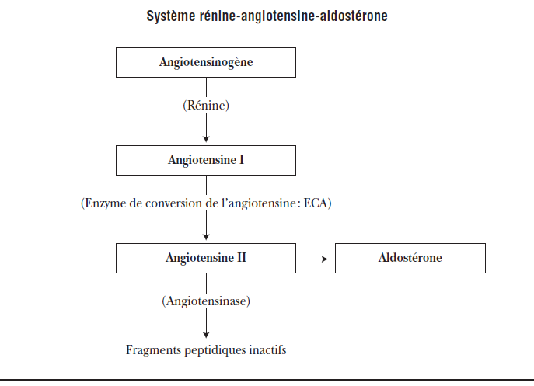

- Activation of the SRAA in the regulation of the GFR
This system is triggered by the release of renin by juxtaglomerular cells .
The juxtaglomerular cells of the afferent glomerular arterioles behave as baroreceptors and the cells of the macula densa play the role of chemoreceptors.
Various stimuli can trigger this system following a drop in blood pressure:
1. Thus, a decrease in blood pressure leads to a reduction in the stretching of the afferent arteriolar wall, and baroreceptors trigger renin secretion. Conversely, an increase in renal perfusion pressure inhibits renin release.
2. In addition, the decrease in GFR that accompanies the drop in blood pressure leads to a decrease in tubular NaCl concentration; the cells of the macula densa ( chemoreceptors) detect this decrease and stimulate the juxtaglomerular cells for the release of renin.
3. Finally, the sympathetic nervous system directly stimulates the release of renin by juxtaglomerular cells via β1 adrenergic receptors .
- Results of RAAS activation
Angiotensin II has two main functions: it causes arteriolar vasoconstriction and stimulates the release of aldosterone.
The vasoconstrictive action of angiotensin II is greater in the efferent arteriole, which has a large number of angiotensin receptors. Vasoconstriction of the efferent arteriole leads to an increase in the glomerular filtration rate (GFR).

On the other hand, aldosterone (which is the final component of the RAAS) increases the reabsorption of Na (and water) and the secretion of K by the chief cells of the distal tubule. It also increases the secretion of H+ by the intercalated cells of the distal tubule.
Although the primary function of the RAAS system is the regulation of blood pressure and extracellular fluid volume, its activation in response to a drop in blood pressure has a beneficial effect on GFR.

2.2. Concept of clearance
The clearance of a substance is the volume of plasma completely cleared of that substance per unit of time. Measuring clearance is a method for assessing renal function in clinical settings.
$$C=\frac{U×V}{P}$$
C : clearance (ml/min) U : concentration in urine
V : urine volume per unit of time; P : plasma concentration
2.3. Secretion and reabsorption
After entering the renal tubule, the primary urine formed during glomerular filtration travels through the renal tubule where its composition is modified by the movement of substances before being excreted in its final form. The movement of substances occurs in two directions:
- From tubules to peritubular capillaries: this is reabsorption
- From peritubular capillaries to the tubules: this is the secretion
In contrast to filtration, secretion and reabsorption are highly selective processes.
Each day, 180 liters are filtered through the kidneys, but only 1.5 liters (urine) are excreted, meaning that over 99% of the fluid must be reabsorbed. Most of this reabsorption occurs in the proximal tubules, with a small portion taking place in the distal segments.
Reabsorption can occur via transepithelial transport (across the cell membrane) or via paracellular transport (between two cells). Transportation can be passive ( not requiring energy) or active.
A substance that enters the renal tubule can be excreted in the urine by filtration, secretion, or both. However, once in the tubule, the substance is not necessarily excreted and may be reabsorbed. Thus, the amount of any substance excreted in the urine is equal to the amount filtered plus the amount secreted minus the amount reabsorbed.
Quantity excreted = Quantity filtered + Quantity secreted - Quantity reabsorbed
2.3.1. Maximum transport curve “Tm”
There is a maximum transport capacity for all substances whose reabsorption is mediated by a transporter. The reabsorption of glucose across the proximal tubular cell is an example, involving a limited number of membrane transport proteins ( Na-glucose cotransporter ).
At plasma glucose concentrations below 300 mg/dL, all filtered glucose is reabsorbed (many transporters are available) and excretion is negligible. At plasma glucose concentrations equal to or greater than 350 mg/dL, the transporters are saturated (this is the maximum transport capacity , Tm ), the filtered glucose cannot be reabsorbed, and it is excreted in the urine; this is glycosuria.
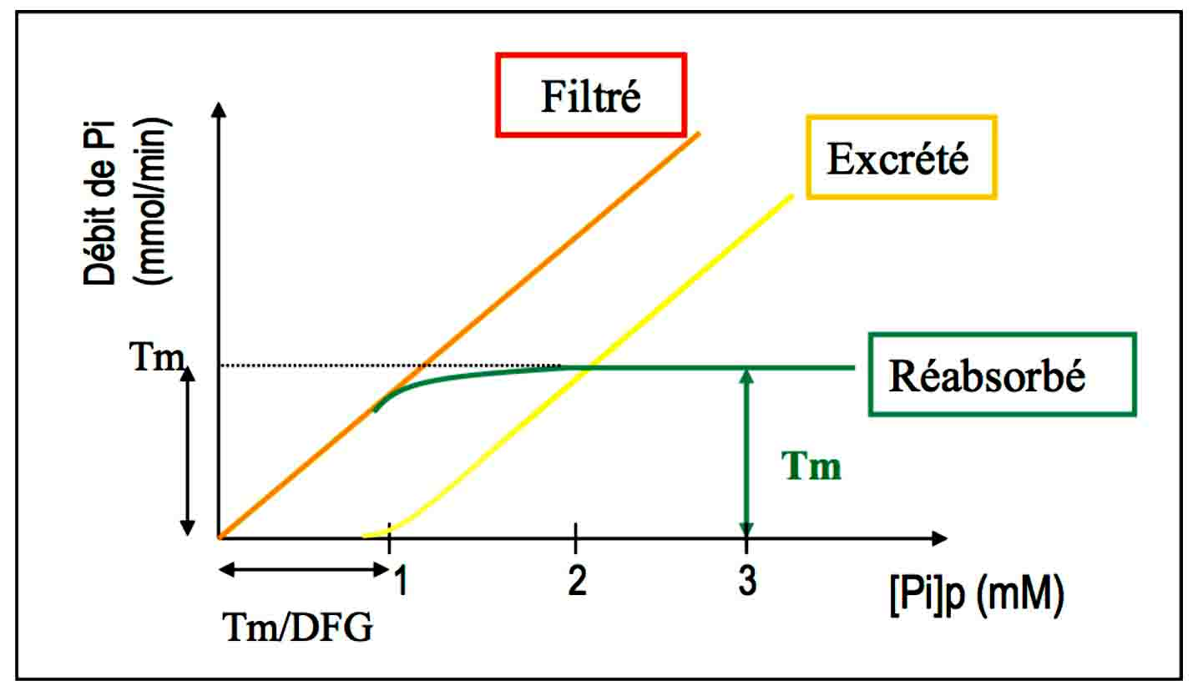

2.3.2 . Sodium Regulation
Sodium filters freely through the glomerular capillaries; the sodium concentration in the tubular fluid within Bowman's space is equal to that of the plasma. Sodium is reabsorbed along the nephron, and a very small portion is excreted in the urine (1% of the filtered amount).
2.3.2.1. Sodium Reabsorption along the nephron:
- The proximal tube
It reabsorbs 2/3, or 67%, of the filtered Na and water. The reabsorption of Na and water in the PCT is exactly proportional; the process is iso-osmotic .
- First part of the proximal tube
Na is reabsorbed by a co-transporter along with glucose, amino acids, phosphates, and lactates. These processes account for the reabsorption of all the filtered glucose and amino acids.
Na is also reabsorbed by countertransport as Na-H exchange. This exchange is directly linked to the reabsorption of filtered bicarbonates (HCO3 ₎ .
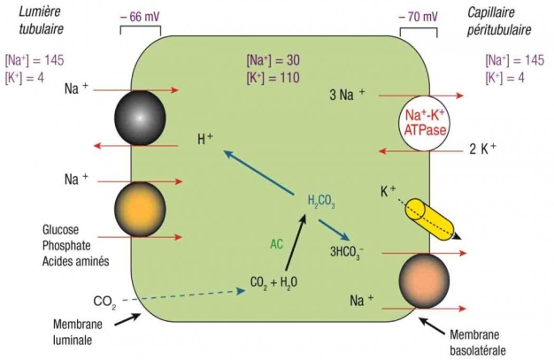
- Middle and final part of the proximal tube
In these segments, Na is reabsorbed with Cl. At this level, glucose, amino acids and HCO3 are completely eliminated from the tubular fluid by reabsorption in the first part of the TCP.
Note : the descending limb of the loop of Henle is impermeable to ions.
- The broad ascending branch of the Henle's Loop
The loop of Henle reabsorbs 20% of the filtered Na. Reabsorption is facilitated by the Na-K-2Cl cotransporter.
The ascending limb of the loop of Henle is impermeable to water, so NaCl is reabsorbed without water. The [Na] and osmolarity of the tubular fluid therefore become lower than those of the plasma. This segment is consequently called the diluting segment .
- Distal tube and collecting duct
Together, they reabsorb 12% of the filtered Na.
- First part of distal tube
is called the cortical diluent segment . It reabsorbs Na+ via a NaCl co-transporter. It is impermeable to water, like the ascending limb of the loop of Henle. Thus, the reabsorption of NaCl without water further dilutes the tubular fluid.
- Last part of distal tube and collecting canal
This segment consists of two types of cells with different functions:
Main cells: reabsorb Na and _{H2O} and secrete K.
These cells are the site of action for the following hormones:
- Aldosterone: increases Na+ reabsorption and K+ secretion. The effects of aldosterone take several hours to develop because they require the synthesis of new membrane proteins. 2% of Na+ reabsorption is aldosterone-dependent.
- Antidiuretic hormone (ADH): increases water permeability by directing the insertion of aquaporins. In the absence of ADH, chief cells are virtually impermeable to water.
Intercalated cells : secrete H and reabsorb K. Aldosterone increases H secretion by intercalated cells.
2.3.3. Potassium Regulation
⁺⁾ balance is reached when urinary excretion exactly equals dietary intake. Potassium excretion varies considerably, from 1% to 110% of the filtered amount, depending on dietary intake, aldosterone levels, and acid-base status. Potassium is filtered, secreted, and reabsorbed by the nephron.
2.3.3.1. Movements of Potassium along the nephron
- Proximal tubule: reabsorbs 67% of K ⁺ along with Na ⁺ and water
- Broad ascending limb of the Henle's Loop
Reabsorbs 20% of the filtered K+ by involving the co-transporter Na ⁺ -K ⁺ -2Cl.
- Distal tube and collecting duct: reabsorb or secrete K depending on its intake from the food ration.
2.3.3.2. K Reabsorption
This occurs only in cases of potassium depletion; in such cases, potassium excretion can drop to as low as 1% of the filtered amount. The kidneys attempt to conserve as much potassium as possible. The mechanism involves the HK-ATPase exchanger in intercalated cells.
2.3.3.3. K secretion: Takes place at the level of principal cells and depends on dietary intake of Potassium, aldosterone levels and acid-base status.
- Distal potassium secretion mechanism
Active transport: from K inwards the cell by the Na-K-ATPase pump of the basolateral membrane of the main cell. This mechanism maintains a high intracellular concentration of K.
Passive secretion: of K in the tubular lumen. The magnitude of this passive secretion is determined by the concentration gradient of K between the principal cell and the tubular fluid.
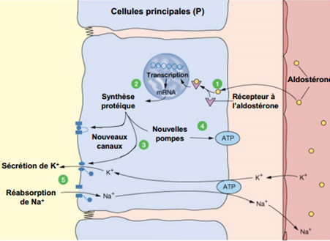
- Factors modifying distal K secretion:
Potassium intake through diet:
A diet rich in K increases the intracellular concentration of K, so the induction force for secretion also increases.
A diet low in potassium decreases intracellular potassium concentration, thus reducing potassium secretion. Conversely, intercalated cells are stimulated to reabsorb potassium.
Aldosterone levels:
Increases K secretion by chief cells by increasing Na reabsorption across the luminal membrane and increasing its expulsion by the basement membrane Na-K-ATPase pump (capillary side).
Hyperaldosteronism increases K secretion and causes hypokalemia.
Conversely, hypoaldosteronism decreases K secretion and causes hyperkalemia.
The acid-base state:
In acidosis, there is an excess of hydrogen (H₂) in the blood. H₂ enters the cell through the basement membrane (capillary side) in exchange for potassium (K). Consequently, the intracellular concentration of potassium decreases. The induction force for potassium secretion is reduced, leading to hyperkalemia.
In alkalosis, the opposite phenomenon occurs: due to a hydrogen deficiency in the blood, hydrogen leaves the distal cell through its basal pole in exchange for potassium, which enters. Thus, the increased intracellular concentration of potassium produced leads to an increased induction of potassium secretion, resulting in hypokalemia.
2.4. Water balance
The stability of the extracellular fluid (ECF) hydro-electrolyte composition is essential for proper cell function. Hydro-electrolyte balance is maintained by multiple regulatory mechanisms:
-Secretion of antidiuretic hormone (ADH or vasopressin) which increases the permeability of the renal tubule to water
-Renal mechanisms that allow urine to be diluted or concentrated
-Thirst Mechanism
Water reabsorption is coupled to sodium reabsorption. It occurs passively by osmosis. The permeability of the nephron to water varies from one tubular segment to another and depends on the presence of aquaporins and plasma ADH levels.
ADH, also called vasopressin , is a neurohormone released by the posterior pituitary gland or neurohypophysis. ADH is released following stimulation hypothalamic osmoreceptors.
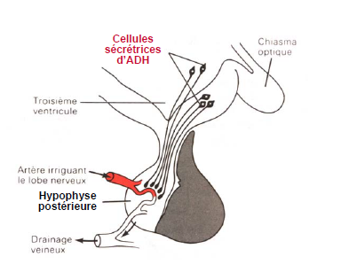

ADH secretion is stimulated by:
The decrease in blood volume (hypovolemia) detected in the right atrium
The decline in blood pressure detected via aortic and carotid baroreceptors
An increase in plasma osmolarity (hyperosmolarity) is detected by hypothalamic osmoreceptors when osmolarity exceeds 300mOsM/l.
Regulation of ADH secretion
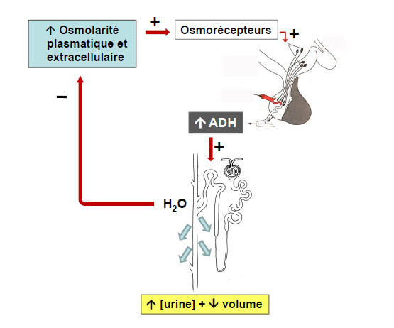

2.4.1 . Urine concentration
In the presence of high ADH levels (SIADH, hemorrhage, dehydration)
- Proximal tube: always permeable to water.
The osmolarity of the glomerular filtrate is identical to that of plasma: 300 mOsm/l
Two-thirds of the filtered water is reabsorbed iso-osmotically along with Na, Cl, HCO3, glucose… etc.
- The descending branch of the loop of Henle: is also permeable to water but not to ions.
- The broad ascending limb of the loop of Henle is permeable to ions but impermeable to water. NaCl is reabsorbed without water, and the tubular fluid is therefore dilute. The fluid leaves the ascending limb with an osmolarity of 100 mOsm/L.
- First part of the distal tube: also impermeable to water, the tubular fluid is further diluted.
- Last part of the distal tube: the The water permeability of this segment is increased by ADH. Water is reabsorbed until the osmolarity of the tubular fluid equals that of the surrounding interstitial fluid: 300 mOsm/L
- The collecting duct: the The water permeability of this segment is increased by ADH. As tubular fluid flows through the collecting ducts, it passes through areas of increasing osmolarity: the corticopapillary gradient, created by the recycling of urea into the inner medulla . Water is reabsorbed until the osmolarity of the tubular fluid equals that of the surrounding interstitial fluid. The osmolarity of the final urine equals that of the loop of Henle: 1200 mOsm/L.
In the absence of ADH, the collecting tube is impermeable to water, and diluted urine is emitted (50mOsm/l).

2.5. Acid-base balance
Acid-base balance, or pH homeostasis, is one of the essential functions of the kidneys because changes in pH affect cellular function. The body's adaptation to pH changes depends on three mechanisms: buffer systems, ventilation (respiration), and renal regulation.
There is a chronological sequence for the activation of these systems. Buffer systems are the first line of defense, limiting large fluctuations. Increased ventilation is a rapid response, capable of addressing nearly 75% of acid-base disturbances. Finally, the kidneys are much slower to activate. They manage all residual pH disturbances.
Acid-base balance is regulated by several mechanisms, namely:
2.5.1. The different buffer systems
As its name suggests, a buffer does not prevent pH changes, but it limits their magnitude. Most of the body's buffers function by binding H+ ions. The buffers are:
Intracellular: These are mainly proteins, ^{phosphate} ions (HPO4-2 ₎ and hemoglobin. The buffering of H ^{+ ions} by hemoglobin releases an HCO3- ion into the red blood cell _{which} ^{then} enters the plasma (exchange with a Cl- ion ⁾ .
Extracellular: These are the bicarbonates produced by the metabolism of CO2 _{which} constitute the most important extracellular buffer system in the body.
2.5.2 . Ventilation and pH
Any change in ventilation will alter the acid-base balance.
CO ₂ + H ₂ OH ₂ CO3 H ⁺ + HCO ₃ ⁻
Hypoventilation (decrease in alveolar ventilation) leads to an increase in PCO2 , therefore dissolved CO2 , and shifts the equation to the right with an increase in H+ ions.
Hyperventilation (increased alveolar ventilation). The subject exhales more CO2, _{thus decreasing} PCO2 . The equation shifts to the left, increasing carbonic acid, decreasing H ^{+ ions} , and therefore increasing pH.
The ventilation system will be able to adjust the pH via two stimuli: H ⁺ and _{PCO22}
H + stimulates aortic and carotid chemoreceptors, which in turn stimulate the bulbar respiratory centers , leading to increased ventilation and consequently the elimination of CO2 _{and} increased transformation of H ^{+ ions} into _{H2CO3 .}
H ⁺ does not cross the blood-brain barrier, so it is converted into CO2 . CO2 stimulates central chemoreceptors , leading to increased ventilation.
This chemosensitive stimulation will allow it to respond to any change in pH and plasma _{CO2} .
2.5.3. Renal regulation of pH
The kidneys take over the 25% of compensation that the lungs did not perform. They do this in two ways:
  - excretion or reabsorption of H+ ions
  - increase or decrease in the rate of reabsorption of HCO3- ions
In the case of metabolic acidosis:
- The HCO3- ions are reabsorbed, which increases the pH.
- H+ ions are secreted into the tubular lumen using direct and indirect active transport
2.5.3.1. Reabsorption of _{filtered} HCO3
Occurs in the proximal tubule. H₂ and HCO₃⁻ are produced in the proximal cells according to the following reaction:
CO2 + _{H2O} → _{HCO3​}​
The reaction is catalyzed by intracellular carbonic anhidrase . H is secreted by the H-Na exchanger and the HCO3 is reabsorbed .
In the tubular lumen, the reaction occurs in the reverse direction.
H + _{HCO3} → CO2 + _{H2O}
The reaction is catalyzed by carbonic anhidrase in the brush border. CO2 ₊ H2O _{diffuse} into the cell to restart the cycle.
The result : net reabsorption of filtered HCO3 . However, no net secretion of H results from this process.
An increase in the amount of HCO3 filtered leads to an increase in the rates of HCO3 reabsorption . However, at high plasma concentrations of HCO3 ₍ as in the case of alkalosis) it may happen that the amount filtered exceeds the reabsorption capacity and that HCO3 _{is} excreted in the urine.
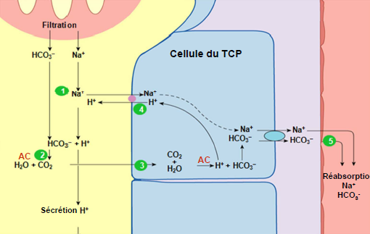

2.5.3.2 . Excretion of H+ ions in the form of _{titratable} acidity _{H2PO4-}
It is a mechanism that extracts the fixed H produced by the catabolism of proteins and phospholipids.
H₂ and HCO₃⁻ _{are} produced in the cell from CO₂ _{and} H₂O . H₂ is secreted by an H-ATPase and the HCO3​ is reabsorbed into the blood.
The secreted H combines with HPO4-2 _{to} form HPO4- ^{which is} excreted as _{titratable} acidity.
This process results in a net secretion of H₂ and a net reabsorption of newly synthesized HCO₃⁻ . As a consequence of this H₂ excretion, the urine pH gradually decreases.
2.5.3.3. Excretion of H ^{+ ions} in the form of _{NH4}
This is another mechanism that extracts the fixed H produced by the catabolism of proteins and phospholipids.
NH3 produced in _{kidney} cells from glutamine passes into the tubular lumen following its concentration gradient.
H₂ and HCO₃⁻ _{are} produced in the cell from CO₂ _{and} H₂O . H₂ is secreted by an H-ATPase and combines with NH₃ _{to} form NH₄⁺ , which is then excreted. HCO3​ is reabsorbed into the blood.
A decrease in tubular pH increases the excretion of H in the form of NH4 . In the case of acidosis, there is an adaptive increase in the synthesis of NH3 _{in} order to increase the elimination of H.
In the case of metabolic alkalosis:
HCO3- ions are excreted and H+ ions are reabsorbed, which tends to decrease the pH.
The implementation of these renal compensations for metabolic abnormalities is slower and can take nearly 48 hours before being noticeable.

