CARDIOVASCULAR
PHYSIOLOGY

Course outline
- Overview of the cardiovascular system
- Functional Anatomy
- Basic parameters
- Cardiac electrophysiology
- Ventricular pressure-volume curve
- Cardiac function curves
- Heart cycle
- Blood pressure regulation

Presentation of the cardiovascular system
The cardiovascular system is defined by the British physiologist William Harvey as a closed loop, such that blood is pumped by the heart into a series of vessels called arteries and returns to it through another series called veins. This constitutes two circuits, both originating and terminating in the heart. These two circuits are organized as follows:
Lesser circulation or pulmonary circulation (low-pressure circulation) : includes pumped blood via the right ventricle through the lungs and then to the left atrium, it is then sent to the,
Greater circulation or systemic circulation (high-pressure circulation) where blood is pumped from the left ventricle through all the tissues and organs of the body (except the lungs) and then from there to the right atrium.
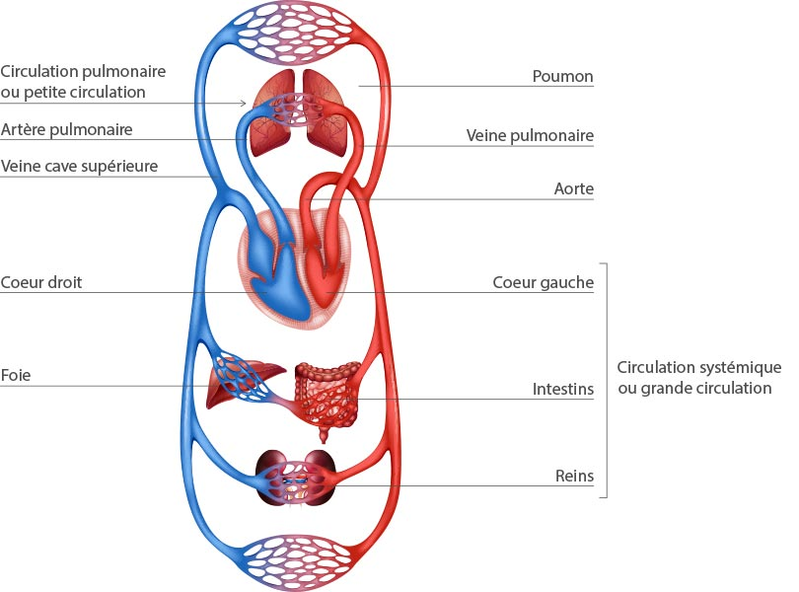
Figure 1 : Pulmonary circulation and systemic circulation

The cardiovascular system's role is to ensure adequate blood flow to the various organs and tissues of the body; that is, to transport oxygen and substances absorbed in the digestive tract to the different tissues of the body and to return the
dioxide is transported to the lungs, and other metabolic products to the kidneys. It also contributes to the regulation of body temperature and enables the distribution of various hormones that regulate cellular activities.

- Functional Anatomy
The cardiovascular system has three structural components: a circulatory fluid (blood), a network of vessels, and a muscular pump (heart).
1.1. The heart
The heart is a hollow muscle with four chambers , two atria and two ventricles. It is divided longitudinally by the interventricular septum into two functional parts: the right heart and the left heart.
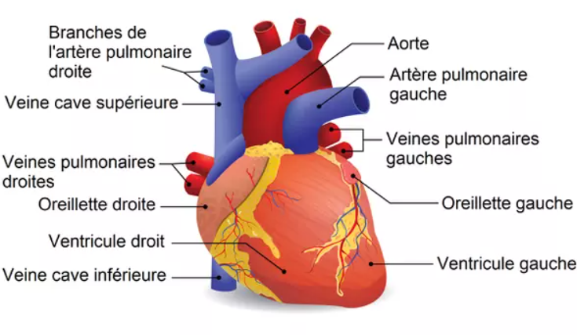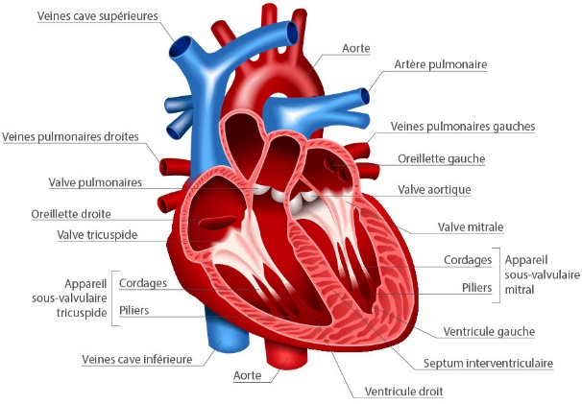
Figure 2 : Anatomy of the heart

The heart has four valves, two atrioventricular valves separating the atria from the ventricles and two semilunar valves separating the ventricles from the large arteries.
atrioventricular valves are respectively the right atrioventricular valve or tricuspid valve separating the right atrium from the right ventricle and the left atrioventricular valve or bicuspid valve or mitral valve separating the left atrium from the left ventricle.
These valves control the flow of blood from the atria to the ventricles and prevent its regurgitation.
The semilunar valves are respectively the aortic valve which separates the left ventricle from the aorta and the pulmonary valve which separates the right ventricle from the pulmonary artery.

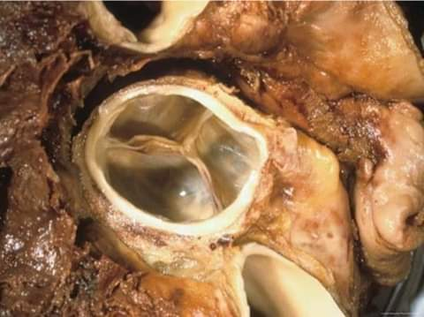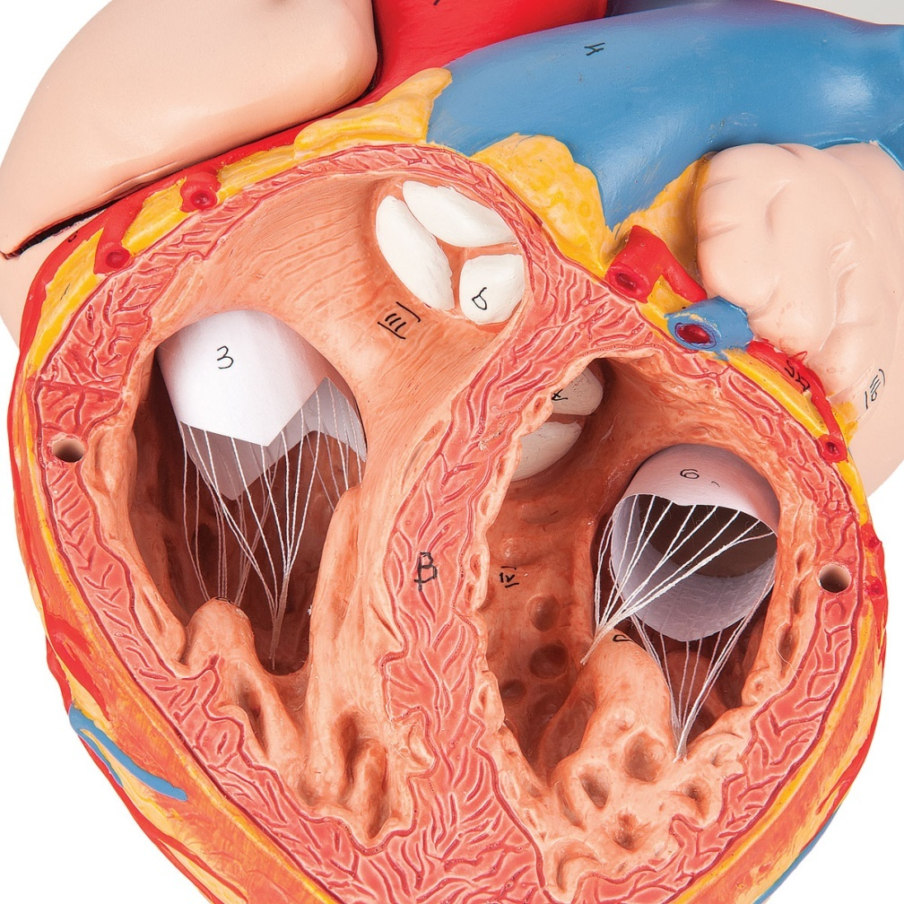
Valves atrio-ventriculaire
Valvule sigmoïde
Figure 3 : Atrioventricular valves and semilunar valves
Blood flows from the atria to the ventricles, but not the other way around, and from the ventricles to the arteries, but not the other way around. Blood circulation in the heart is unidirectional.
The opening and closing of the valves are completely passive . They depend on the pressure difference on each side of the valve.

The heart also contains a series of blood vessels, two large arteries: aorta and pulmonary trunk and three large veins: superior vena cava, inferior vena cava and pulmonary vein.
1.2. Nodal tissue and cardiac automatism
The cardiac muscle, also called the myocardium, is a striated muscle with rhythmic and automatic contractions . This automaticity specific to the cardiac muscle is due to the existence of a specialized muscle tissue called nodal tissue which spontaneously produces an electrical signal that can stimulate neighboring cells.
The latter consists of two cell clusters:
- Node sinus Or Keith and Flack “pacemaker”
- Atrioventricular node or Aschoff-Tawara node
These two clusters are extended by the beam of His which splits into two branches constituting the Purkinje network .

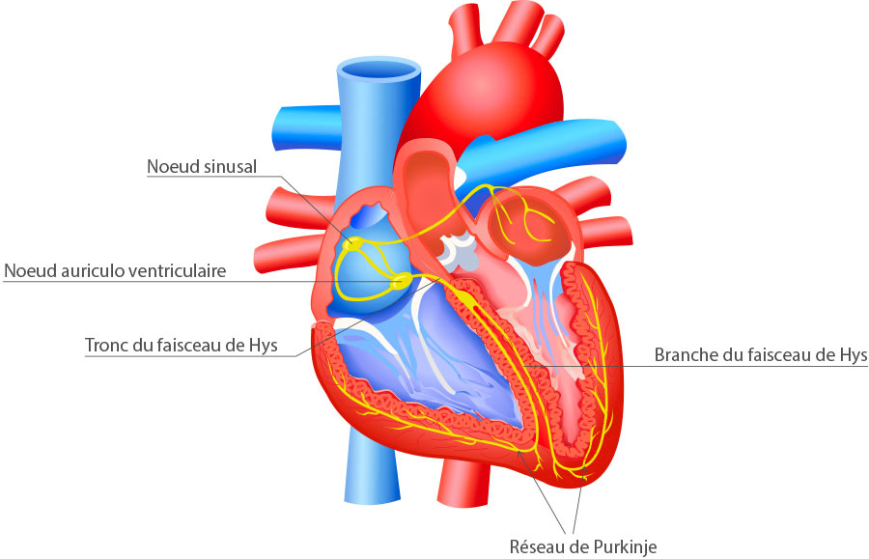
Figure 4 : Nodal Tissue

1.3. Coronary circulation
The heart's blood supply is provided by vessels called coronary vessels. These shallow vessels, located on the surface of the ventricles, are the heart's nourishing vessels. They provide oxygen and nutrients and rid tissues of metabolic waste:
Two coronary arteries, right and left : which originate from the aorta above the aortic valve. The branches of these arteries are intramyocardial.
The coronary veins drain venous blood towards the superior vena cava via the sinus venosus.
Myocardial perfusion occurs during diastole (cardiac relaxation).
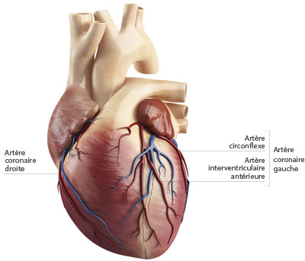
Figure 5 : Coronary Circulation

1.4. Innervation of the heart
It is provided by:
Vagus nerve (parasympathetic): cardio-moderator described as a permanent vagal brake slowing the heart rate, the force of contraction and the excitability of the nodal tissue, thus resulting in bradycardia.
Sympathetic nerve : cardio-accelerator increasing heart rate, contraction force and excitability of nodal tissue resulting in tachycardia.

1.5. Structure of the heart wall
The heart wall comprises, from the outside in
1.5.1. The pericardium
A serous tunic on the outside that surrounds the heart, formed, like all serous membranes, of two layers of fibrous tissue.
- outermost leaflet, much looser, leaving space for the heart's movements
- inner layer or visceral layer or epicardium
A thin pericardial film fills the space between the two layers and acts as a lubricant between the heart and the sac that surrounds it, supporting the heart by cushioning the beats.

1.5.2. The myocardium
Thick muscular tunic made up of cardiac muscle cells or cardiomyocytes endowed with four fundamental properties: excitability, contractility, conductivity and automaticity .
Contractile myocardial cells are elongated, branching muscle fibers with transverse bands identical to striated muscle cells.
The functional unit of the myocardial cell is the sarcomere, which has a structure similar to that of skeletal muscle. Intercalated discs contain gap junctions that allow for the rapid electrical propagation of action potentials. It is thanks to these junctions that the myocardium behaves like an electrical syncytium .
1.5.3. The endocardium
Mucous membrane inside which lines the internal cavities of the heart and continues as the inner tunic of the arteries and veins. The endocardium lines the internal cavities of the heart and covers the chordae tendineae of the heart valves. It is separated from the underlying myocardium by a subendocardial connective tissue layer containing nerves, small blood vessels, and fibers of the Purkinje network .
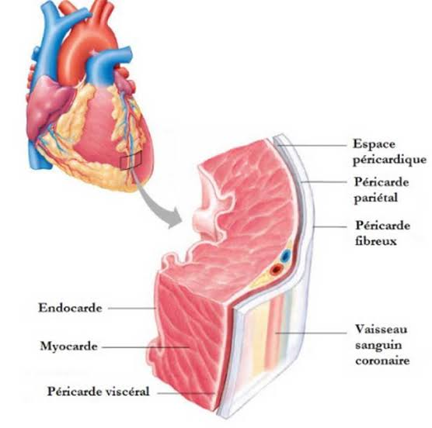
Figure 6 : Structure of the heart wall

1.6 . Structure of blood vessels
The vascular system plays an active role in regulating blood pressure and distributing blood flow to different tissues.
Arteries and veins are made up of three layers, from the inside out: the intima (endothelium + basement membrane), the media (smooth and elastic muscle fibers), and the adventitia (connective tissue, nerve endings of the autonomic nervous system). The thickness of these layers varies depending on the type of vessel. The walls of capillaries are composed of only a single layer of vascular endothelium.
The structural and functional characteristics of the vessels vary according to the region; we thus distinguish five categories:
1.6.1. Systemic arteries : supply oxygenated blood to the organs, have thick walls and are subjected to high pressures. The blood volume contained in the systemic arteries is called: high-pressure volume or constrained volume.
1.6.2. Arterioles: these are the smallest arterial bronchi, they are the site of the strongest resistance of the cardiovascular system and possess a purely sympathetic autonomic innervation.
1.6.3. Capillaries: are the site of exchanges of nutrients, water and gases. They group together in networks called: capillary beds .
1.6.4. Venules: possess autonomous innervation, participate in regulation of blood flow.
Note : The flow of blood from an arteriole to a venule is called microcirculation.
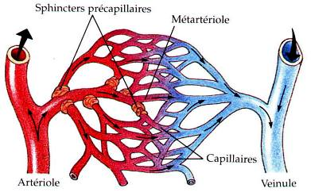
Figure 7 : Microcirculation
1.6.5 . Veins : They carry deoxygenated blood from the organs to the heart. They have the lowest blood pressure and contain the largest proportion of the blood in the cardiovascular system (85%). The blood volume contained in the veins is called the low-pressure volume or unconstrained volume. Veins have valves that prevent the backflow of blood.
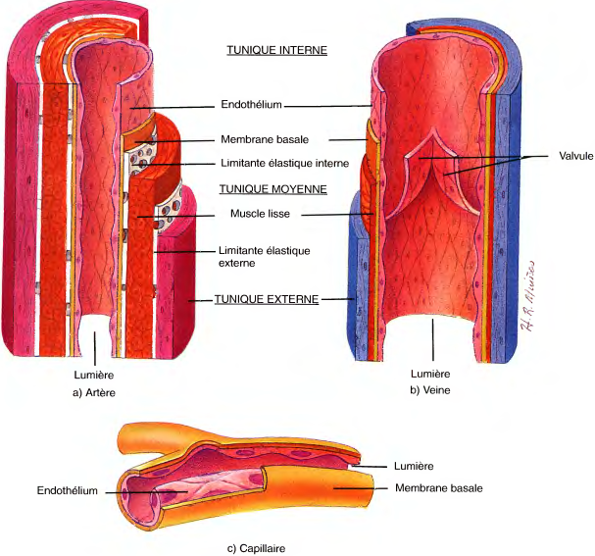
Figure 8 : Structure of the walls of different blood vessels

- Basic parameters
3.1. Blood flow velocity:
It is expressed by the following equation:
$$V=\frac{Q}{A}$$
V: velocity cm/s
Q: Blood flow rate ml/min
A: surface area of ^{the} cross-section cm²
At any level of the cardiovascular system, velocity is directly proportional to blood flow and inversely proportional to cross-sectional area. Therefore, flow velocity is greater in the aorta (small cross-sectional area) than throughout the capillaries (large cross-sectional area). The lower flow velocity in the capillaries facilitates the exchange of substances across the capillary walls.
2.2. Blood flow
Is the volume of blood that flows through a vessel, an organ, or the entire cardiovascular system per unit of time (L/min). This is the amount of blood ejected from the heart per unit of time (1 min).
It is expressed by the following equation:
$$Q=\frac{∆P}{R}$$
$$Débit sanguin=\frac{Pression artérielle moyenne-Pression auriculaire droite}{résistance périphéique totale (RPT)}$$

It is the difference in pressure that causes blood flow. Blood thus flows from areas of high pressure to areas of low pressure.
The flow rate is inversely proportional to the resistance in the blood vessels.
2.3. Vascular resistance
This is the force that opposes the flow of blood, and it results from the friction of the blood against the walls of the vessels. Because friction is most prevalent in the peripheral circulation, far from the heart, it is generally referred to as peripheral resistance.
According to Hagen-Poiseuille's law:
$$R=\frac{ 8 . l . η}{π . r4}$$
Three important factors can influence resistance: blood viscosity, as well as the length and diameter of the vessels.
R: resistance
η : blood viscosity
l : total length of blood vessels
r : radius of the vessel,
Resistance is directly proportional to blood viscosity and vessel length, and inversely proportional to the fourth power of vessel radius.
Arterioles are the main determinants of peripheral resistance because their diameter can vary.
2.3.1. Parallel resistance: This is illustrated by systemic circulation, where each organ is supplied by an artery branching off from the aorta. The total resistance of this parallel arrangement is expressed by the following equation:
$$\frac{1}{R totale}=\frac{1}{R1}+\frac{1}{R2}+…+\frac{1}{Rn}$$
The total resistance is lower in either of the arteries taken individually.
2.3.2. Resistance in series: This is illustrated by the arrangement of blood vessels within a given organ. Each organ is supplied by a large artery that branches into smaller arteries, then arterioles, capillaries, venules, and veins arranged in series. The total resistance is the sum of the individual resistances, as indicated by the following equation:
R _{total} = R _{arteries} + R _{arterioles} + R _{capillaries} + R _{veins}
2.4. Flow methods
Near the walls of a tube or conduit, the flow of liquids is slowed by friction; on the other hand, the closer one gets to the center, the freer and faster the flow. Near the walls, the blood appears almost motionless, while it flows rapidly in the middle; this phenomenon is called laminar flow.
When blood flows through a vessel that changes diameter abruptly or whose walls are covered with roughness or protrusions (for example, lipid deposits in atherosclerosis), laminar flow becomes irregular. This phenomenon, called turbulent flow , significantly increases resistance; it produces noises that can be heard with a stethoscope, unlike laminar flow, which is silent.
2.5. Compliance or capacitance
This is the distensibility of the vascular wall in response to an increase in volume or pressure. It is described by the following equation:
$$C=\frac{∆V}{P}$$
C: capacitance ml/ mmHg
V: volume ml
P: pressure mmHg
It describes how volume changes in response to a change in pressure. It is directly proportional to volume and inversely proportional to pressure. It is much greater in veins than in arteries. Veins therefore contain a larger quantity of blood (unconstrained volume).

2.6. Blood pressure
As blood flows through the systemic circulation, the pressure gradually decreases due to the resistance opposing the flow. Thus, the pressure is higher in the aorta and lower in the vena cava.
The greatest drop in pressure occurs at the level of the arterioles since they are the site of the greatest resistance.
Blood pressure is pulsatile and reaches its peak during systole; when measured at this stage, it is called systolic blood pressure : occurs when the heart contracts and blood is ejected into the arterial system.
During diastole, blood is forced into circulation by elastic arteries that contract and blood pressure reaches its lowest level; this is diastolic blood pressure.
The successive expansion and contraction of elastic arteries during each cardiac cycle creates the pulse.
The difference between systolic pressure and diastolic pressure is called: differential pressure .
Mean arterial pressure (MAP) is approximately equal to diastolic pressure plus one-third of the pulse pressure.
The low pressure in the capillaries (from 45 to 15 mmHg ) protects their fragile walls from rupture while allowing adequate exchanges.
Venous pressure is non-pulsatile. It is low, approximately 10% of arterial pressure, due to the cumulative effects of resistance.
Venous return is facilitated by the contraction of vascular smooth muscle, the large lumen of the veins which generates reduced resistance against the propulsion of blood, and the contraction of skeletal muscles which tighten around the veins, increasing venous pressure and causing the venous valves to open. When the muscles relax, these valves close to prevent blood from flowing backward.
2.7. Heart rate
This is the number of heartbeats per minute. Normal heart rate varies depending on the animal species, size, age, and physical activity.
Bradycardia : a decrease in heart rate
Tachycardia : increased heart rate
Chronotropic effects relate to heart rate, a negative chronotropic effect decreases heart rate by decreasing the discharge rate of the sinoatrial node; conversely, a positive chronotropic effect increases heart rate by increasing the discharge rate of the sinoatrial node.
2.8. Heart rate
This refers to the genesis of the heart's electrical activity and the regularity of its propagation. The origin of the heart rhythm can be: sinus (sinus node), junctional ( atrioventricular node ), ventricular ( ventricular cardiomyocytes ), ectopic (from the muscle cells of the atrium), or artificial: an artificial pacemaker , a stimulator implanted near the heart and connected to it with electrodes. A rhythm of sinus origin is considered physiological.
2.9. Systole and diastole
The contraction of the myocardium is called systole and its relaxation is called diastole. Thus, there are:
- right and left atrial systoles (followed by diastoles), practically simultaneous,
- right and left ventricular systoles (followed by diastoles), also almost simultaneous.
Atrial activity precedes ventricular electrical activity by a few fractions of a second.
In common practice, we speak of cardiac “systole” or “diastole” to refer to ventricular systole or diastole, encompassing the contraction or relaxation of both ventricles.

- Cardiac electrophysiology

  - Electrical properties of the myocardium
3.1.1. Automaticity
It is due to the electrogenic tissue, which is the nodal tissue. It is the automatic generation of electrical impulses and the regularity of the transmission of these impulses to all cardiac structures.
3.1.2. Excitability
This is the myocardium's ability to trigger an action potential in response to an incoming depolarizing current. It changes during an action potential; these changes are described as refractory periods.

3.1.2.1. Absolute refractory period
It begins with the rise of the action potential and ends after the plateau. It reflects the time during which no action potential can be initiated regardless of the strength of the stimulus. These refractory periods are what make the heart muscle resistant to tetany .

3.1.2.2. Period effective refractory
Slightly longer than the PRA and represents the period during which there can be no potential action conducted.
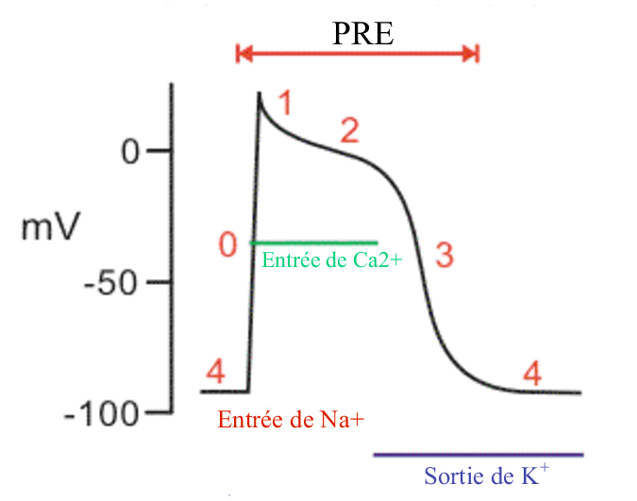
Figure 9 : Effective refractory period

3.1.2.3. The relative refractory period
This is the period immediately following the absolute refractory period, during which repolarization is not quite complete. During this period, an action potential can be initiated but requires a larger inward current than usual.
3.1.3. Contractility
This is the intrinsic capacity of the cardiac muscle to generate force at a given length of muscle. It can be assessed by the ejection fraction (stroke volume/end -diastolic volume ). It is also called inotropism . Agents that can increase contractility are said to have a positive inotropic effect. Conversely, all agents that produce a decrease in contractility are said to have a negative inotropic effect.
3.1.4. Conductivity
This is the ability of cardiomyocytes to conduct and transmit an electrical current from one cell to another through GAP junctions.
The Dromotropic Effect This concerns the conduction velocity through the atrioventricular node . Agents that increase conduction velocity through the AV node, accelerating the passage of action potentials from the atria to the ventricles, are said to have a positive dromotropic effect . Conversely, all agents that decrease conduction velocity are said to have a negative dromotropic effect .
3.2. Electrocardiogram
The heart is periodically the site of electrical activity. This electrical activity is represented by a propagating wave of depolarization. The ECG is the recording of this electrical activity. The action potential is the summation of the membrane potentials of each myocardial cell. The ECG tracing results from the electrical activity in the myocardium, not in the cardiac conduction tissue. The electrical tracing records the variations in this summation.
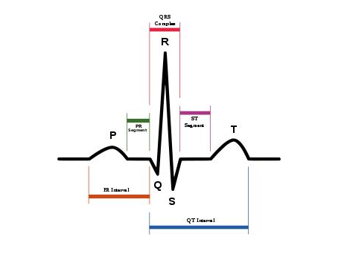
Figure 10 Electrocardiogram
The P wave: Represents the depolarization of the auricular muscle. Does not include atrial repolarization, which is masked by the QRS complex.
The QRS complex: Represents the depolarization of the ventricles.
The T wave: corresponds to the ventricular repolarization.
The PR interval: this is the interval that goes from the beginning of atrial depolarization to the beginning of the Q wave and corresponds to the time that elapses between the depolarization of the atria and the depolarization of the ventricles.
It increases when the conduction velocity through the atrioventricular node is decreased, as in heart block.
It varies with heart rate: an increase in heart rate shortens the PR interval.
The ST segment: isoelectric and represents the period during which the entire ventricular muscle is depolarized.
The QT interval: goes from the beginning of the Q wave to the end of the T wave and represents the entire period of depolarization and repolarization of the ventricles.
3.3. Cardiac action potentials
3.3.1. Myocardium and Purkinje system
They have resting membrane potentials of approximately -90 mV, which approaches the potassium equilibrium potential. Action potentials are long, especially in the ventricles, with a duration of 300 ms.
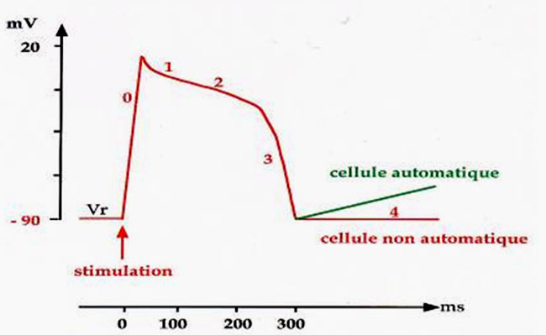
Figure 11 : Action potential in the myocardium and Purkinje system

Phase 0: Rising action potential
This is due to a transient increase in sodium conductance, resulting in an inward sodium current that depolarizes the membrane. At the peak of the action potential, the membrane potential approaches the equilibrium potential of sodium.
Phase 1: Initial repolarization
Caused in part by an outward current K ions leaving the cell and on the other hand by the decrease in Na conductance.
Phase 2: Plateau of action potential
Caused by the transient increase in the conductance of Ca ⁺² resulting in an inward current of Ca ⁺² (necessary for contraction) and a decrease in the conductance of potassium.
During the plateau, the incoming and outgoing currents are approximately equal, so the action potential remains stable at the plateau level.
Phase 3: Repolarization
During this phase, the conductance of Ca decreases but that of K increases and consequently predominates.
The high conductance of K results in a large current flowing out of K which hyperpolarizes the membrane, bringing it back towards the equilibrium potential of K.
Phase 4: Resting membrane potential
During this phase, the Na-K-ATPase pump restores Na and K concentrations across the cytoplasmic membrane and the membrane potential approaches the equilibrium potential of K.
3.3.2. Sinoatrial node (pacemaker)
It is the basis of cardiac automaticity. It does not have a constant resting potential and exhibits a phase 4 that depolarizes spontaneously and gradually.
atrioventricular node , the bundle of His , and the Purkinje network are latent pacemakers that can exhibit automaticity and compensate for the sinoatrial node when it fails. The intrinsic rate of depolarization, and consequently the heart rate, is slower in the AV node and the Purkinje network than in the SA node.
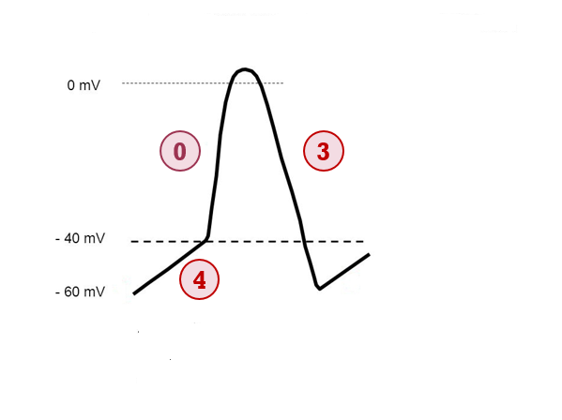
Figure 12 : Action potential in the sinoatrial node

Phase 0: Rising action potential
The ionic base of phase 0 in the SA node is different from that of the ventricle. It is caused by an increase in Ca conductance resulting in an inward Ca current which drives the membrane action potential towards the Ca equilibrium potential.
Phase 3: Repolarization
Caused by an increase in the conductance of K resulting in an outward current from K which leads to the repolarization of the membrane.
Phase 4
The action potential of the sinoatrial node exhibits a phase 4 which, instead of showing a constant resting potential, undergoes spontaneous depolarization down to -40mV
This depolarization is due to an increase in Na conductance, resulting in an inward Na current called If (f = funny ), which gradually raises the membrane potential to the opening threshold of voltage-gated calcium channels. Ca ⁺⁺ ions then enter the cell, triggering the action potential.
- Excitation-contraction coupling
The action potential propagates across the cell membrane into the T-tubules.
During the plateau of the action potential, the conductance for Ca ⁺² is increased and the latter enters the cell from the extracellular fluid.
This calcium influx triggers the release of additional Ca2 ^{+ ions} from the sarcoplasmic reticulum. The amount of calcium released by the sarcoplasmic reticulum depends on the magnitude of the incoming current.
Ca²⁺ binds to troponin C, thus triggering contraction. The strength of this contraction is proportional to the amount of Ca²⁺ ^{in the} brain. intracellular.
Relaxation occurs when Ca ⁺² is returned to the RS by a Ca ⁺² ATPase pump.
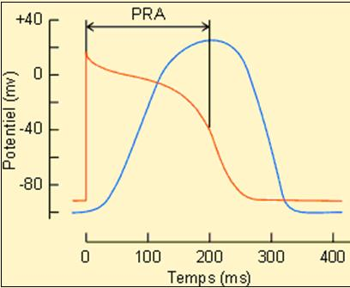
Figure 13 : Excitation-contraction coupling

- Ventricular pressure-volume loop: cardiac revolution
It is constructed by combining systolic and diastolic pressure curves.
The diastolic pressure plot describes the relationship that exists between diastolic pressure and diastolic ventricular volume.
The systolic pressure plot is the corresponding relationship between systolic pressure and ventricular stroke volume.
By combining these two traces, we obtain the pressure-volume loop which describes the cycle of contraction, ejection, relaxation and ventricular filling.
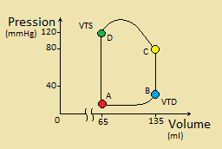
Figure 14: Ventricular pressure-volume loop

Filling (AB): As soon as ventricular pressure falls below atrial pressure, the mitral valve opens (point A) and ventricular filling begins. During this phase, ventricular volume increases and returns to its value of approximately 140 ml (end-diastolic volume).
Isovolume contraction (BC):
It begins during diastole at point B. The ventricle is full, its volume is approximately 140 ml (end-diastolic volume). Ventricular pressure is low because the ventricular muscle is relaxed. Under the effect of stimulation, the ventricle contracts and ventricular pressure increases. Since all the valves are closed, blood cannot be ejected from the ventricle, and the contraction is therefore said to be isovolumic .
Ventricular ejection (VEE): The aortic valve opens at point C when the pressure in the ventricle exceeds the pressure in the aorta. Blood is ejected into the aorta, and the ventricular volume decreases. The volume of blood ejected is called the stroke volume.
Relaxation Isovolumic (DA): At point D, when ventricular pressure drops to a value lower than aortic pressure, the aortic valve closes and the ventricle relaxes. Since all the valves are closed again, the relaxation is said to be isovolumic .
- Length-tension relationship ( Frank Starling relationship )

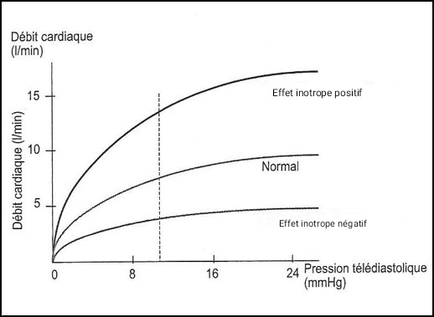
Figure 15: The Frank- Starling relationship and the positive and negative inotropic effects

It describes the effect of ventricular cell length on contraction force. The sarcomere length is determined by the maximum number of cross-bridges that can be formed between the different myocardial fibers, thus determining the maximum tension (contraction force) generated.
Frank- Starling relationship is the mechanism that adapts cardiac output to venous return. It describes the increase in cardiac output (stroke volume: the volume of blood ejected by the ventricle with each contraction) that occurs in response to an increase in venous filling pressure ( end-diastolic volume ). Since the ventricles do not empty completely of blood during contraction, a more powerful contraction can increase stroke volume by increasing ventricular emptying. The ventricle contracts more intensely during systole when its filling was greater during the preceding diastole.
It is based on the length-tension relationship such that any increase in VTD leads to an increase in fiber length and consequently an increase in the tension generated (contraction force) and the ejection volume.
Increased contractility ( positive inotropism ) leads to an increase in cardiac output for any value of venous pressure, right atrial pressure, or end-diastolic volume (EDV). Decreased contractility ( negative inotropism ) leads to a decrease in cardiac output for any value of venous pressure, right atrial pressure, or EDV.
- Ventricular muscle preload is equivalent to end-diastolic volume or venous filling pressure. When ventricular filling increases, the myocardial fibers are stretched; this is the Frank- Starling relationship .
- Afterload : is equivalent to aortic pressure; it opposes blood flow and increases when aortic pressure increases. The contraction velocity at a given length of the myocardium is maximal when there is no afterload .

- Cardiac and vascular function curves
These are simultaneous representations of cardiac output and venous return as a function of end-diastolic volume and right atrial pressure.
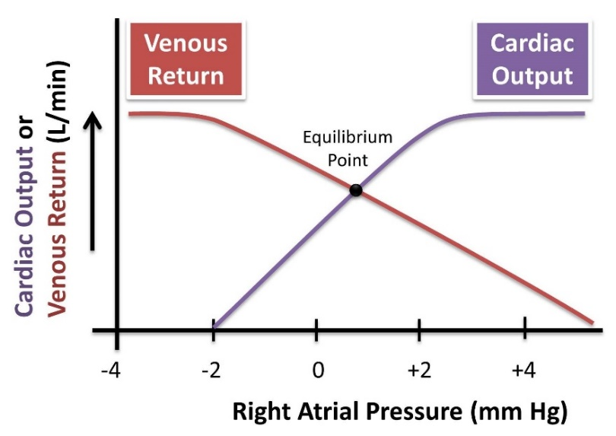
Figure 16: Cardiac and vascular functional curves

7.1 . Cardiac function curve (cardiac output)
Frank Starling 's relationship to the ventricle.
It shows that cardiac output increases as a function of end-diastolic volume ; this is a consequence of the length-tension relationship in cardiac muscle fibers.
Changes in end-diastolic volume are a major mechanism for modifying cardiac output.
7.2. Vascular Functional Curve
It describes the relationship between flow through the vascular system (or venous return) and right atrial pressure.
- Average systemic pressure
Measured when the heart is experimentally stopped. It is equal to the right atrial pressure when there is no flow in the cardiovascular system.
Under these conditions, cardiac output and venous return are zero and the pressure is the same throughout the cardiovascular system.
It is increased by any increase in blood volume and decreased by any decrease in blood volume.
- Slope of the vascular functional curve
It is determined by resistance throughout the vascular system.
An increase in venous return indicates a decrease in total peripheral resistance (TPR). Thus, when TPR is decreased (by vasodilation of arterioles) at constant right atrial pressure, there is an increase in venous return, since vasodilation of arterioles allows blood to flow from the arteries to the veins and ultimately to the right atrium.
7.3. Combination of cardiac and vascular functional curves
The point where the two curves intersect is the equilibrium point or steady-state point . Equilibrium occurs when venous return equals cardiac output. Cardiac output can be changed by modifying the cardiac functional curve, the vascular functional curve, or both.
a. Inotropic actions modify the cardiac functional curve

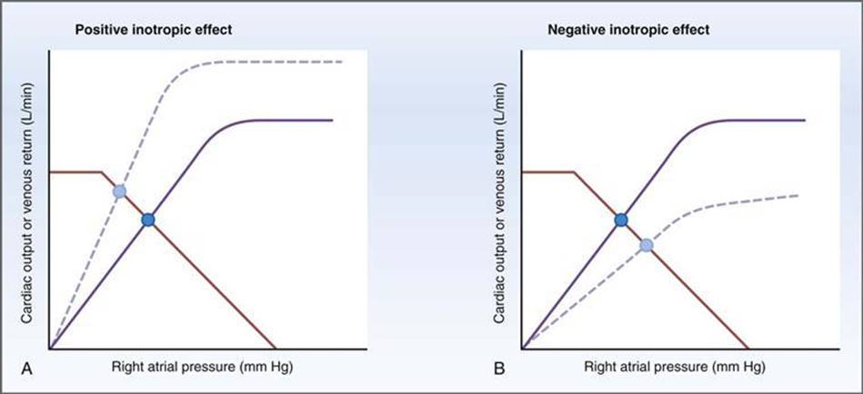
Figure 17: Variations in the cardiac function curve

Positive inotropic agents (e.g., digitalis) increase contractility and consequently increase cardiac output. The equilibrium point shifts toward a higher cardiac output and a correspondingly lower right atrial pressure. Right atrial pressure is lowered because a greater volume of blood is ejected from the heart with each beat (increased stroke volume). Negative inotropic agents will have the opposite effects.
b. Variations in blood volume modify the vascular functional curve
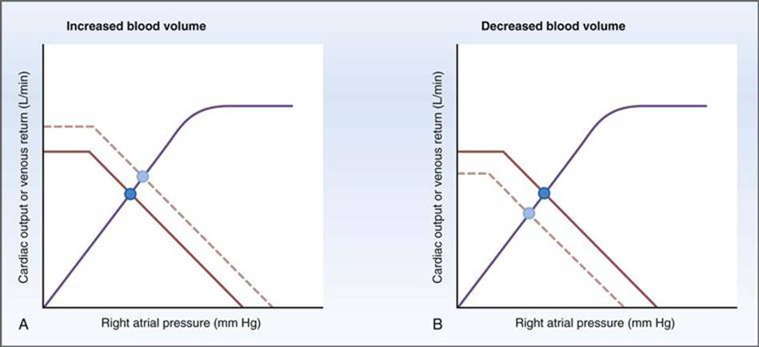
Figure 18: Variations in the vascular functional curve

The increase in blood volume raises the mean systemic pressure, shifting the vascular functional curve to the right, parallel to itself. A new equilibrium point is established where both right atrial pressure and blood flow are increased.
A decrease in blood volume (e.g., hemorrhage) would have opposite effects: a drop in mean systemic pressure and a shift of the vascular functional curve to the left, parallel to itself. A new equilibrium point is established where both right atrial pressure and blood flow are reduced.

c. Changes in RPT modify both the cardiac and vascular functional curves
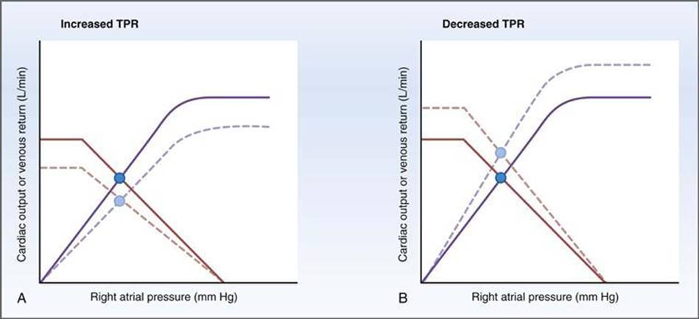
Figure 19: Simultaneous variations in cardiac and vascular functional curves

Changes in RPT affect both curves simultaneously.
An increase in pulmonary artery regurgitation (PARR) causes both a decrease in cardiac output and venous return. Increased PARR (arteriolar vasoconstriction) leads to decreased venous return because blood is retained on the arterial side. The increase in aortic pressure (increased afterload) causes a downward shift in the cardiac function curve, since the heart pumps blood against a higher pressure.
A decrease in pulmonary artery regurgitation (PARR) leads to both an increase in cardiac output and venous return. A lower PARR (arteriolar vasodilation) results in increased venous return, as blood flows more easily from the arterial to the venous side and ultimately to the right atrium. The decrease in aortic pressure (reduced afterload) causes an upward shift in the cardiac function curve, since the heart pumps blood against a lower pressure.
As a result of these simultaneous changes, a new equilibrium point is established where both cardiac output and venous return are increased.

- Heart cycle
It describes the various electrical and mechanical events that occur cyclically in the heart. The vertical lines indicate seven phases:
  - Atrial systole
This follows the P wave.
Contributes to ventricular filling but is not essential to it.
The increase in atrial pressure caused by atrial systole is reflected by the " a" wave of the venous pulse.
Ventricular filling by atrial systole is the source of the fourth heart sound, which is inaudible in a normal adult.
  - Isovolumic ventricular contraction
It begins after the start of the QRS complex.
As soon as ventricular pressure exceeds atrial pressure, the atrioventricular valves close . Their closure corresponds to the first heart sound. The mitral valve closes before the tricuspid valve, so the first heart sound can be split.
Ventricular pressure increases isovolumetrically due to contraction, but blood is not ejected because the aortic valve remains closed.
  - Rapid ventricular ejection
Ventricular pressure reaches its maximum value.
As soon as ventricular pressure exceeds aortic pressure, the aortic valve opens. The pressure gradient between the ventricle and the aortic valve causes a rapid ejection of blood into the aorta.
Ventricular volume decreases considerably because most of the ejection volume is ejected during this phase.
Atrial filling begins.
The beginning of the T wave marks the end of contraction and the end of rapid ventricular ejection.
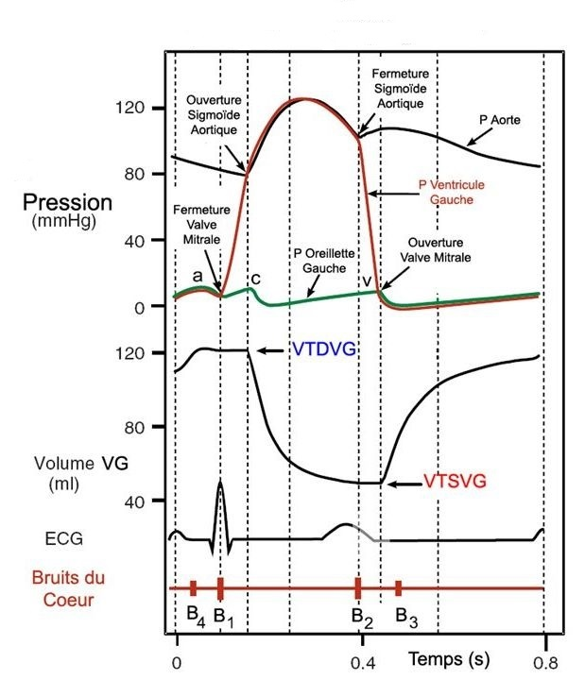
Figure 20: Cardiac cycle
  - Slow ventricular ejection
The ventricle continues to eject blood, but more slowly.
Ventricular pressure begins to drop
Aortic pressure also drops because blood flows rapidly from the large arteries to the smaller ones.
Atrial filling continues.

  - Isovolumic ventricular relaxation
Ventricular repolarization is complete.
The aortic valve closes, followed by the closure of the pulmonary valve. The closure of both semilunar valves corresponds to the second heart sound. Inspiration causes the second heart sound to split.
atrioventricular valves remain closed.
Ventricular pressure drops rapidly because the ventricle is now relaxed. And ventricular volume remains constant because the valves remain closed.
  - Passive rapid ventricular filling
As soon as ventricular pressure falls below atrial pressure, the mitral valve opens and the left ventricle begins to fill.
Aortic pressure continues to decrease as blood continues to flow towards the smaller arteries.
The rapid flow of blood from the atria to the ventricles causes the third heart sound, which is physiological in children but associated with a condition in adults.
  - Slow ventricular filling (Diastasis)
The ventricle continues to fill, but more slowly.
The duration of diastasis depends on heart rate. An increased heart rate reduces ventricular filling time.

- Blood pressure regulation
Blood pressure regulation occurs through multiple mechanisms:
9.1. The baroreflex
The baroreflex involves rapid neural mechanisms. It is responsible for the minute-by-minute regulation of blood pressure. This mechanism triggers tonic vasoconstrictive activity, which accounts for vasomotor tone.
Baroreceptors are stretch receptors located in the walls of the carotid sinus near the bifurcation of the common carotid arteries.
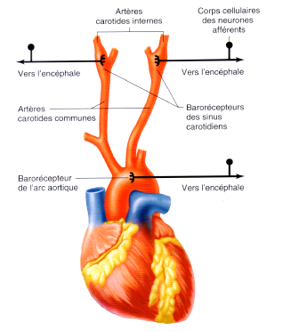
Figure 21: Location of carotid and aortic baroreceptors

Baroreflex mechanism
Distension of the carotid sinus walls due to increased blood pressure.
Baroreceptors are most sensitive to changes in blood pressure, and therefore a rapidly increasing blood pressure triggers a greater response than a high but constant pressure.
Other baroreceptors located in the aortic arch respond to increases but not to decreases in BP.
Stretching of the baroreceptors stimulates the hypoglossal nerve, which carries information to the vasomotor center of the brainstem.
The reference point for mean blood pressure in the vasomotor center is 100 mmHg . Therefore, when blood pressure exceeds this value, the vasomotor center coordinates to reduce it through a series of autonomic nervous system responses.
The responses consist of an increase in parasympathetic activity on the heart and a decrease in sympathetic activity on the heart and blood vessels. The following four actions, working together, lower blood pressure back to its normal value.
- Decreased heart rate: result of an increase in cardiac parasympathetic tone and a decrease in cardiac sympathetic tone.
- Decreased contractility: resulting from a decrease in cardiac sympathetic tone, associated with a decrease in heart rate, it leads to a decrease in cardiac output and also causes a drop in blood pressure.
- Decreased vasoconstriction of arterioles: resulting from a decrease in sympathetic activity. Therefore, the TPR decreases, thus lowering blood pressure.
- Decreased vasoconstriction of the veins: resulting from a decrease in the sympathetic action of venous relaxation. There is an increase in blood volume at low pressure (unconstrained), and the mean systemic pressure consequently decreases.

The baroreflex is a negative feedback system : the combined action of these mechanisms to lower mean arterial pressure to its normal value results from traction exerted on the baroreceptors of the carotid sinus and a decrease in the signal sent to the vasomotor center.
9.2. Renin-Angiotensin-Aldosterone System
It is a slow hormonal system involved in the long-term regulation of blood pressure by adjusting blood volume.
A drop in renal perfusion pressure causes a release of renin, thus triggering the Renin-Angiotensin-Aldosterone system.
Angiotensin II has two actions: it stimulates the release of aldosterone by the adrenal cortex and causes vasoconstriction of arterioles, thus increasing the RPT.
Aldosterone increases the reabsorption of Na and water by the distal tubule, thereby increasing blood volume and consequently BP.
9.3. Other regulators of the PA
9.3.1. Cerebral ischemia
In the case of cerebral ischemia, the concentrations of CO2 _{and} H ⁺ in brain tissue increase. The chemoreceptors of the vasomotor center respond by increasing both sympathetic and parasympathetic activity. Contractility and transient retinal circulation (TRC) increase, but the heart rate decreases due to the dominance of parasympathetic activity. In this case, blood pressure can rise to a life-threatening level.
Due to peripheral vasoconstriction, the flow to other organs is significantly reduced in an attempt to preserve blood supply to the brain.
9.3.2. Carotid and aortic chemoreceptors
They are located near the bifurcation of the common carotid arteries and along the aortic arch. These chemoreceptors have very high _{O2} consumption and are therefore very sensitive to hypoxia.
The drop in BP leads to a reduction in the supply of O2 to chemoreceptors, which then send information to the vasomotor center to stimulate the regulatory mechanisms of BP.
9.3.3. Vasopressin (antidiuretic hormone ADH)
It is involved in regulating blood pressure in response to bleeding but not in the minute-by-minute regulation of normal blood pressure. The decrease in blood volume (hypovolemia) detected by receptors located in the atria triggers the release of ADH. ADH is a potent vasoconstrictor that increases transpulmonary circulation (TPC) as well as water reabsorption in the distal convoluted tubule (DCT) and the collecting ducts of the kidney.

9.3.4 . Atrial natriuretic peptide (ANP)
It is released by the atria in response to an increase in atrial pressure. PNA is a potent inhibitor of vascular smooth muscle contraction, causing dilation of the arterioles and a decrease in transpulmonary artery regurgitation (TPR). PNA inhibits renin secretion and causes the kidneys to excrete an increased amount of salt and water, which reduces blood volume and tends to lower blood pressure back to its normal value.

