Veins

Arrangement and structure

Structure
Veins have thin, compressible walls; when engorged, they are cylindrical or moulded to the neighbouring organs.
They exhibit internal bulges that give them a bumpy appearance: valves generally arranged in pairs: geminate valves, absent in the pulmonary veins; the trunk of the vena cavae (in most species) is highly developed in the veins of the limbs.
The largest venous trunks are straight, but medium- and small-calibre veins are highly tortuous.

General arrangement
Veins become progressively larger and fewer in number as they approach the heart.
Veins are much more numerous than arteries and have a larger calibre, as well as more elastic walls. As a result, the entire venous system has twice the capacity of the arterial system.

Course and relationship to the ateries
Deep veins are most often associated with arteries.
Superficial or subcutaneous veins form an extensive network with no arterial equivalent (they are important because of the functional compensatory mechanisms they can provide in the event of circulatory difficulties, such as obstruction or surgical ligation).
Deep veins are generally more numerous than their arterial counterparts.
The veins that run alongside the arteries are generally superficial in relation to them.

Venous drainage
Roots, from which the venous trunks are formed, and tributaries, which provide collateral blood supply.
Venous anastomoses are more numerous and even more significant than those of the arteries (they connect the subcutaneous network with the deep network or various veins within the same network).

Structure
Three layers form the wall of the veins, from the outside inwards: the adventitia, the media and the intima.
The wall of the veins is better supplied with blood than that of the arteries; the vasa-vasorum extend right up to the endothelium, which means they are less prone to degeneration.
The innervation consists of nerve networks arranged in delicate plexuses, dotted with tiny ganglia.

Cranial vena cava (vena cava cranialis) and its tributaries
The tributary branches of the cranial vena cava drain the head, neck, thorax and upper limbs ( Figure1 ). The cranial vena cava is usually single (except in rabbits, which have two cranial vena cavae) and is formed, at the entrance to the thorax, by the convergence of the right and left jugular veins and the right and left subclavian veins.
There are five tributaries of the superior vena cava in the horse
• The internal thoracic vein.
• The vertebral, deep cervical and costocervical veins (satellites of the arteries).
• The right azygos vein.

The root of the superior vena cava receives lymph from the thoracic duct, which carries lymph from the body’s tissues into the bloodstream.
The superior vena cava passes through the superior mediastinum to the right of the brachiocephalic trunk and opens into the right atrium.
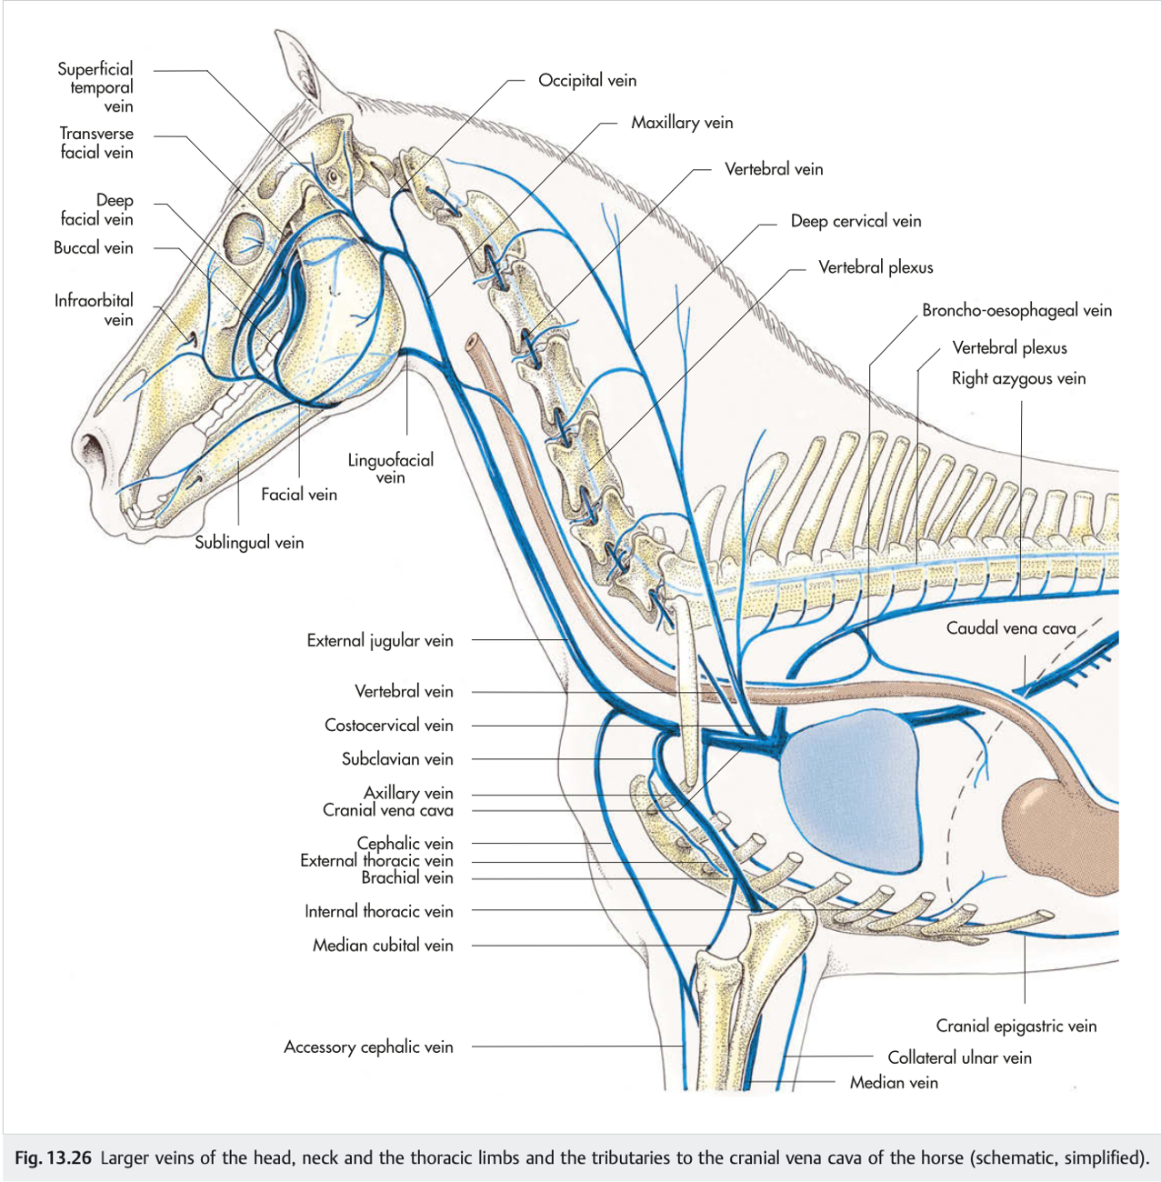
Figure1 : Main veins of the head, neck and forelimb, and tributaries of the superior vena cava (simplified diagram)

Veins of the head and neck
The veins of the head can be divided into those located within the cranial cavity and those located outside the cranial cavity. The veins of the head outside the cranial cavity generally follow the course of the corresponding arteries. In the horse, tributaries of the facial vein are locally dilated to form three venous sinuses beneath the masticatory muscles. Blood can be drawn from any of these sinuses.

The external jugular vein is formed near the angle of the jaw by the union of the lingual-facial and maxillary veins ( Figure1 ). It runs down the neck, occupying the jugular groove (sulcus jugularis) between the brachiocephalic muscle dorsally and the sternocephalic muscle ventrally. In the cranial and middle thirds of the neck, it is subcutaneous. It is therefore the first choice for blood sampling and intravenous injections in most animals.

In all domestic mammals except horses and goats, there are two pairs of jugular veins ( Figure2 ). In addition to the external jugular vein, these animals have an internal (deep) jugular vein that passes between the common carotid artery and the trachea to join the external jugular vein at the base of the neck.

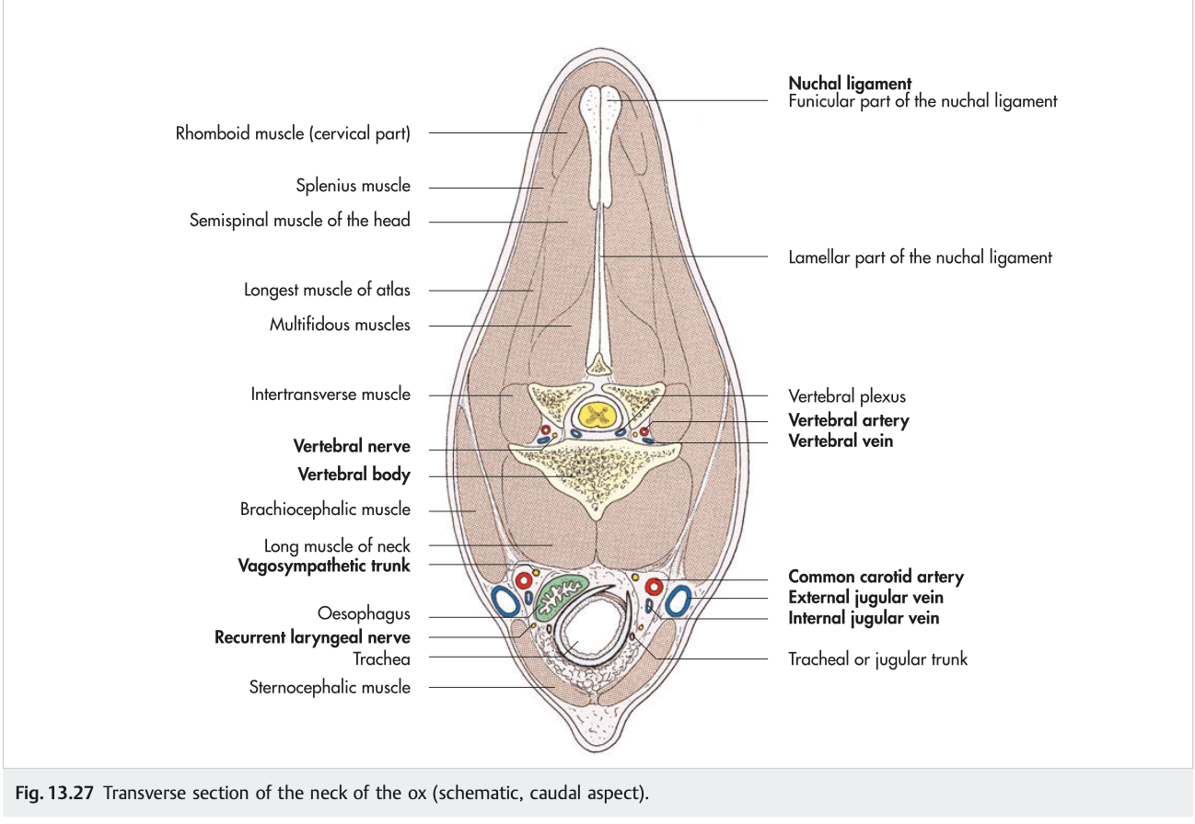
Figure2 : Cross-section of a bovine neck (caudal view, schematic)

Azygos vein (vena azygos)
The azygos vein is formed by the union of the first two lumbar veins and passes through the aortic hiatus into the thorax, where it receives blood from the intercostal veins of the middle and caudal thoracic regions.
Although both the right and left azygos veins are present in the embryo, the arrangement is subsequently commonly simplified: in horses, dogs and cats, it is the right azygos vein that persists ( Figure1 , Figure3 ); in ruminants, both veins are generally present.
The right azygos vein opens into the terminal portion of the superior vena cava; the left azygos drains directly into the coronary sinus.
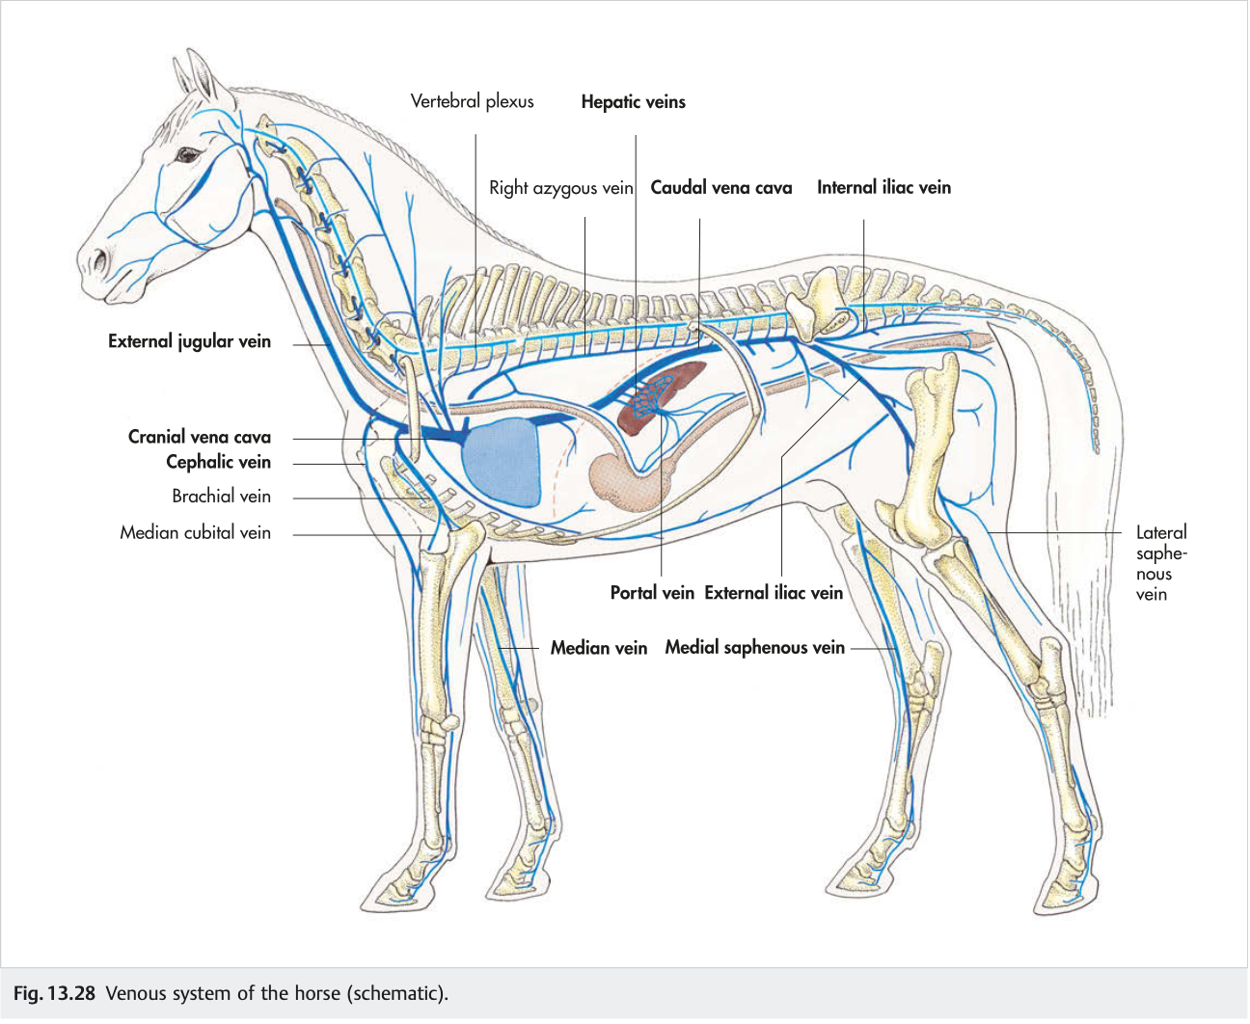
Figure3 : Venous system of the horse

Veins of the forelimb
Each axillary vein serves as the terminal collector for all the veins of the thoracic limb, except for the cephalic vein of the arm, which drains directly into the external jugular vein, and a few veins of the trunk. ( Figure3 ).
A. Veins of the hand
Veins of the fingers: two palmar digital veins.

B. Veins of the metacarpus and carpus.
Organised into two systems: dorsal and palmar.

C. Veins of the forearm and arm
From the carpus, the veins of the thoracic limb form two very distinct systems: one deep, accompanying the arteries, and the other superficial, subcutaneous, without accompanying arteries.

C.1. Superficial veins
Cephalic veins (drain the dorsal surface).
Basilic veins (draining the palmar network).

C.2. Deep veins
These are associated with the arteries.
In the forearm, several median veins run alongside the median artery.
In the arm, the main vein and the brachial vein.
Most of the veins of the upper limb are satellite veins, although they are often duplicated where they accompany the larger arteries. The tributaries of the axillary vein form the deep venous system of the limb, whilst the cephalic vein is the only major superficial vein. It is formed by the union of the deep metacarpal veins on the medial aspect of the carpus and is joined by the accessory cephalic vein, which arises from a venous network on the dorsal aspect of the carpus, in the middle of the forearm. It continues proximally in a subcutaneous position to join the external jugular vein in the lower part of the neck.

At the elbow and shoulder joints, the cephalic vein anastomoses with the median cubital vein. The cephalic vein is the preferred site for intravenous injection in dogs and cats. It runs along the cranial border of the forearm, where it can be palpated by applying pressure to the elbow.

Caudal vena cava
This is the collector of all the veins from the pelvic limbs and the post-diaphragmatic part of the trunk.
It forms below the penultimate lumbar vertebra, through the confluence of the two common iliac veins.
Its tributaries are the lumbar veins, phrenic veins, veins of the genital glands, renal veins and hepatic veins.

Portal vein
This is the vein that collects blood supplied by the celiac artery and the cranial and caudal mesenteric arteries ( Figure4 ).
It is the functional vessel of the liver. It drains the following veins: the cranial mesenteric vein, the caudal mesenteric vein, the splenic vein and the gastric vein.

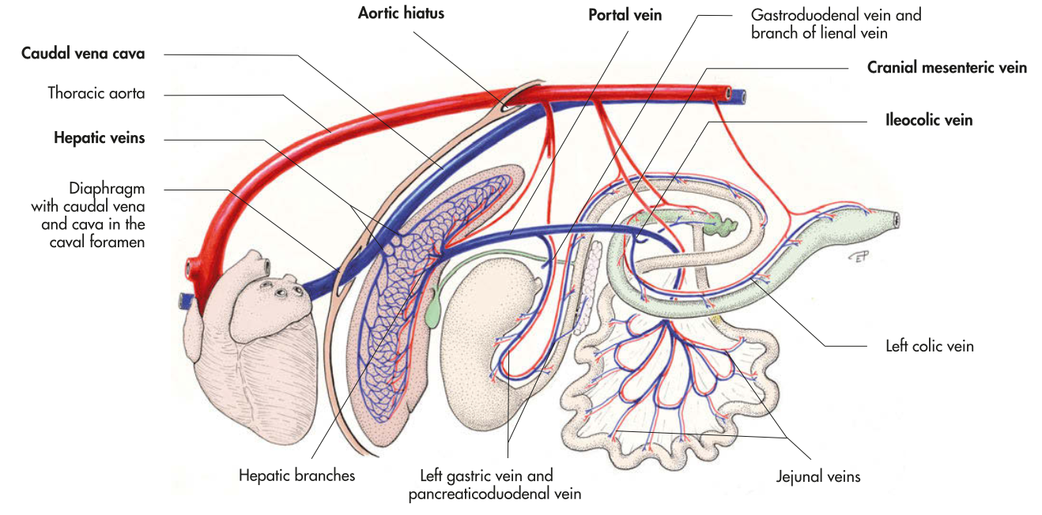
Figure4 : the portal vein in the dog (theoretical diagram) (Konig & Liebich, 2020)

Veins of the pelvic limb

Veins of the foot
Similar to those of the hand
Each toe has two distinct plantar digital veins.
In the metatarsal region, there is a dorsal system comprising the dorsal metatarsal veins and the common dorsal digital veins, and a plantar system comprising the plantar metatarsal veins and the common plantar veins.

Veins of the lower leg and thigh
As in the upper limb, there are two systems:

- A superficial subcutaneous system
The medial and lateral saphenous veins.

- Deep veins
These follow the same pattern as the arteries, though with a few differences.
In the leg, there are two tibial veins, one cranial and the other caudal, which join to form the popliteal vein; this continues into the thigh via the femoral vein.

The deep veins largely follow the course of the arteries, as in the forelimb. The medial and lateral saphenous veins drain into the femoral vein.

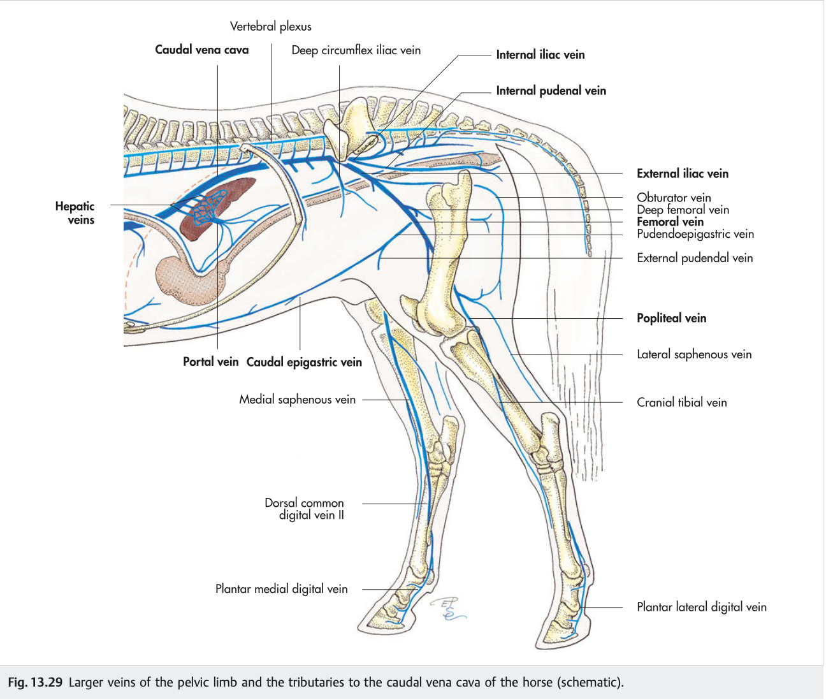
Figure5 : Main veins of the hind limb and tributaries of the caudal vena cava in the horse

