Workshop
Recent Advances in Robot Control
December 03-05, 2023
Speaker: Ahmed CHEMORI LIRMM, CNRS / University of Montpellier
SCHEDULE
Sunday December 3, 2023
Au niveau de la Salle de conférences MALEK BEN NABI
de la Faculté des Sciences de la Technologie Au Campus
AHMED HAMMANI
8:50-9:00 | Opening session
9:00 – 10:20 | Lecture 1  Title:Robotics today: From research to industry | 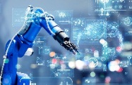
10:20 – 10:40 | Coffee break
10:40 – 12:00 | Lecture 2  Title: Advanced control of wearable rehabilitation exoskeletons | 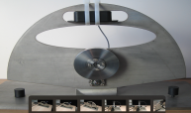

MondayDecember 4, 2023
Au niveau de la Salle de conférences MALEK BEN NABI
de la Faculté des Sciences de la Technologie Au Campus
AHMED HAMMANI
9:00 – 10:20 | Lecture 3  Title: Motion control of high-speed parallel kinematic manipulators for industrial applications | 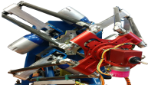
10:20 – 10:40 | Coffee break
10:40 – 12:00 | Lecture 4  Title: Motion control of underwater robots for inspection applications | 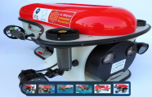

Tuesday December 5, 2023
Au niveau de la Salle de conférences MALEK BEN NABI
de la Faculté des Sciences de la Technologie Au Campus
AHMED HAMMANI
9:00 – 10:20 | Lecture 5  Title: On walking gait control: From human to humanoid robots | 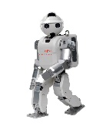
10:20 – 10:40 | Coffee break
10:40 – 12:00 | Lecture 6  Title: Advanced control of underactuated robotic systems | 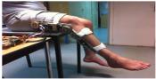

SPEAKER

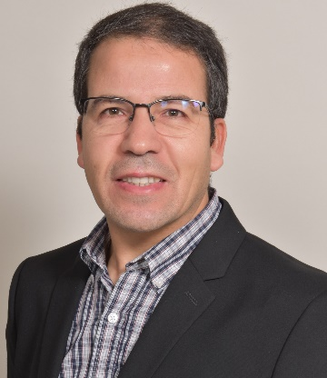
Short Biography: Ahmed Chemori received his M.Sc. and Ph.D. degrees, both in automatic control from Polytechnic Institute of Grenoble, France, in 2001 and 2005 respectively. During the year 2004/2005 he has been a Research and Teaching assistant at Laboratoire de Signaux et Systèmes (LSS - CentraleSupelec) and University Paris 11. Then he joined Gipsa-Lab (Former LAG) as a CNRS postdoctoral researcher. He is currently a tenured research scientist in Automatic control and Robotics for the French National Center for Scientific Research (CNRS), at the Montpellier Laboratory of Computer Science, Robotics and Microelectronics (LIRMM). His research interests include nonlinear (robust, adaptive, and predictive) control and their application in robotics (underactuated, parallel, underwater, humanoid and wearable robots). He is the author of about 160 scientific publications, including international journals, patents, book chapters and international conferences. He served as a TPC/IPC member or associate editor for different international conferences and he organized different scientific events.

