M1 BA/ BN/ PCPP ENGLISH COURS

How to Write an Article in 6 Easy Steps

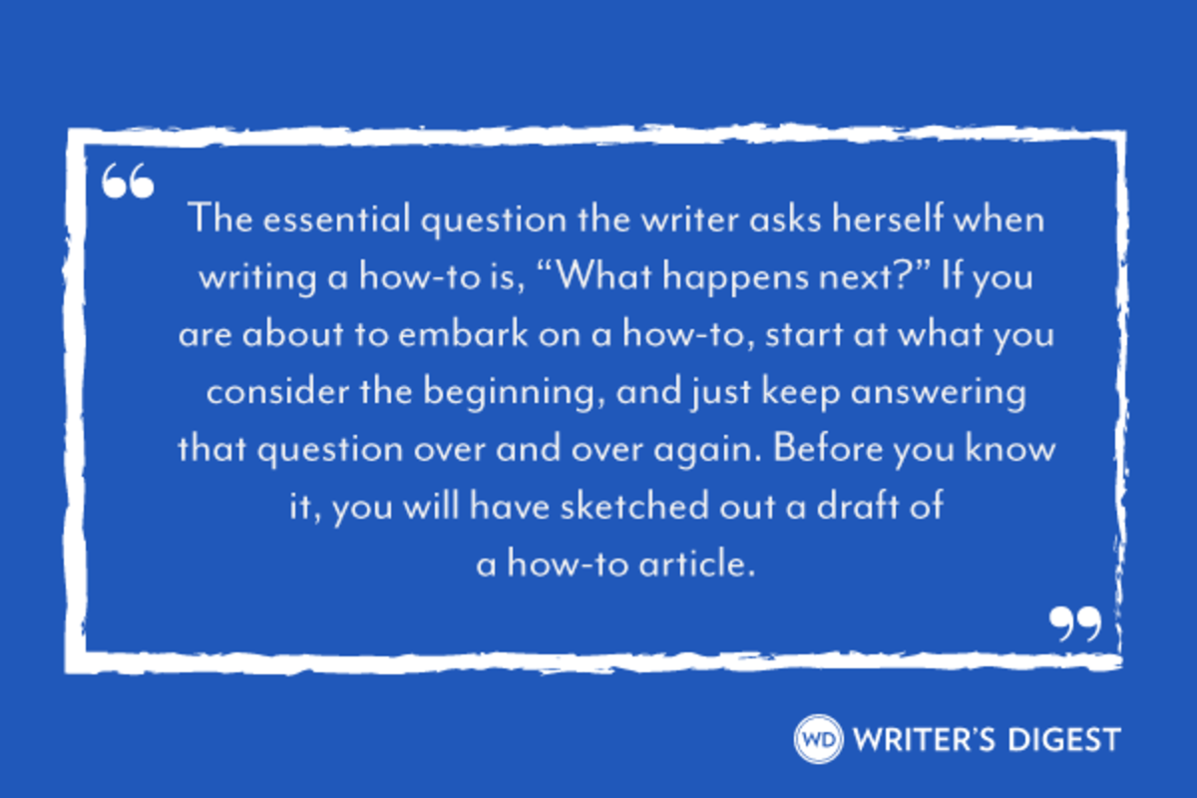
A how-to is written as a sequence—first you do this, and then you do this. The essential question the writer asks herself when writing a how-to is, “What happens next?” If you are about to embark on a how-to, start at what you consider the beginning, and just keep answering that question over and over again. Before you know it, you will have sketched out a draft of a how-to article.

STEP 1: SELECT YOUR TOPIC
Choose a topic that interests you enough to focus on it for at least a week or two. If your topic is broad, narrow it. Instead of writing about how to decorate your home, try covering how to decorate your home in country style on a shoestring budget. That’s more specific and, as such, easier to tackle.
Then write a rough, rough draft, including everything you can think of. Stay loose, avoid getting analytical, and enjoy the process of sharing what you know. When you’re done, you’ll have the bare bones of an article that only you could write. Then put it aside for a while.

STEP 2: ADDRESS YOUR AUDIENCE’S NEEDS
Now, come back to your piece. Switch gears and imagine you’re the reader of this article. Pick three words to describe the audience you want to address (e.g., professionals, single men). As this reader, what questions would you like answered? You might not know the answers yet, but list the questions anyway; you’ll find answers in the next step.

STEP 3: RESEARCH.
Research will ground your article in fact. Good details to include with your how-to are:
- Statistics
- Quotes by well-known people
- Definitions
- Anecdotes (short, illustrative stories about yourself or someone else)
- Quotes and examples from people like the reader, or from popular books on the subject
- References to other media (film, television, radio)
- References to local venues or events (if for a regional/local publication)
- Helpful tools, resources or products (if many, consider creating a sidebar)
Collect everything you have gathered and put it in a folder, an electronic document, a notebook or whatever you like. Don’t forget to keep track of sources in case you are later asked by an editor to verify them. You may want to sift through your research at a separate sitting from gathering it. Or just go ahead and sprinkle your research in right when you find it. It’s a lot like cooking—play around until you feel you have it “just right.”

STEP 4: TIGHTEN YOUR DRAFT
Keeping your audience in mind, write a tighter draft incorporating the new supporting information you’ve collected. Sometimes what you’ve learned in Steps 2 and 3 may compel you to start over with a completely fresh draft. Or you may just want to revise what you have as you proceed, retaining a nice conversational tone by directly addressing your audience.
This time when you read your draft, ask yourself: Is it working? Is it too general, too lightweight, uninteresting, unclear or choppy? If so, comb some of your favorite publications for how-to articles. What techniques are those writers using that you might employ?

STEP 5: MAKE IT SPECIFIC
Double-check to see that you’ve included every pertinent step in the process. How-to articles have to be thorough. You want your reader to walk away knowing exactly how to make that Thanksgiving dinner on a shoestring budget, execute that rugby tackle, or locate great accommodations.
If your narrative goes on and on, or off in too many directions, break it down into key points indicated with subheads (as in this article). Synthesizing complicated information and breaking it down into steps is especially crucial for online writing, and is also a trend in print.

STEP 6: READ, REVISE, REPEAT
Read the draft of your how-to article out loud to a supportive friend. Then, ask her a series of questions: Does she now understand the process? Are there any steps missing? Is there anything else she would like to know about the subject? Could she do the task herself? With your friend’s suggestions in mind, use your best judgment in deciding what changes, if any, need to be made.
Here’s a quick list to help you catch errors or omissions:
- Did you adequately describe the ingredients/supplies needed in order for the reader to complete the task?
- Did you include all the important steps?
- Is the order logical?
- Did you use words that indicate sequence: first, next, then?
- Did you warn readers of possible pitfalls?
Rewrite, read aloud, rewrite, read aloud, rewrite, find a proofreader and, only when you’re satisfied you’ve written an effective how-to article, submit your piece to an appropriate publication with a short cover letter.

